This time I decided to do something that only appeared in the book as a photo-shopped quilt. Before fracturing I added fabric frames to the panels.
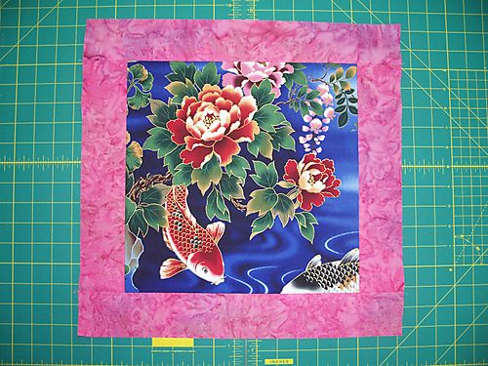
Framed panel
The fish panels were cut 12" square and the frames were cut 2 1/2" wide. Then I cut the panels at a 45 degree angle.
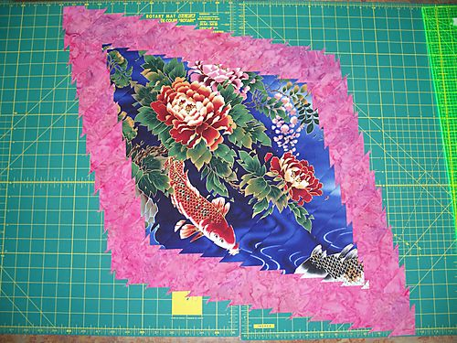
First strip set
.

I really like the way this strip set looks when set on point. I'll have to make another fracture that only goes this far.
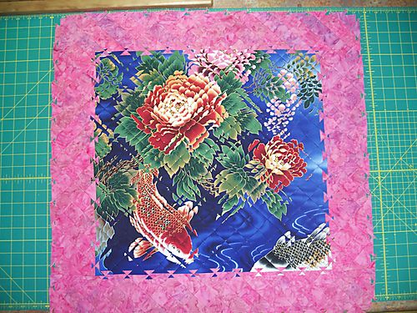
Before trimming

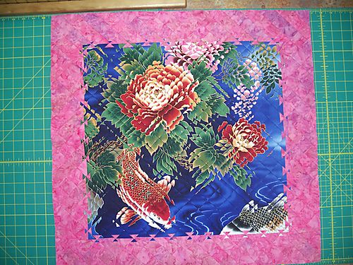
After trimming

The extra seams from the added frames made pressing the seams open harder to do, but it wasn't prohibitive to the process. And the boundary between the panel and the frame adds some extra interest to the piece. I'll definitely do this again. Now I need to figure out how I want to finish this quilt and get it done.

