Hinterberg Classic hand quilting frame
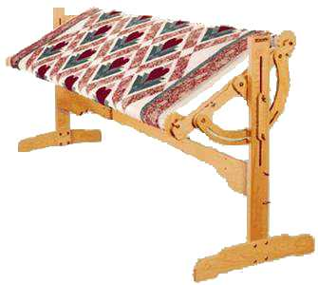
This mint-condition gem is constructed using solid kiln-dried maple and premium grade laminated hardwood. The three-roller design allows a quilter to precisely tension the quilt top and backing independently. This eliminates the need for basting!
Features include:
- muslin aprons attached to poles, making it easier to attach a quilt to the frame;
- 6 large ratchets for tensioning;
- height-adjustable from 30½ to 43 inches;
- wide range of tilt adjustment;
- work area measures 93 X 21 inches;
- 'flip-over top' can turn completely upside-down without disturbing height & tilt adjustments;and
- top tilts to a vertical position to save space when not in use.
Original price: $500
Asking $150 OBO
Contact: Vickiesmith722@gmail.com

