

 | This makes a 12" block ! | 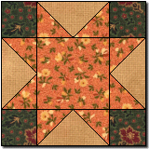 | Please abide by the Terms and Conditions of use! :o)

** Preparing the Pieces and Sewing the Block **

 | 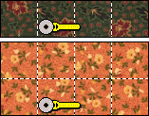 | Cut the Color 2 3-1/2" x 14" strip into four 3-1/2" squares, and the Color 1 7" x 14" strip into eight 3-1/2" squares...

 | 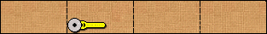 | Next cut the Color 3 3-1/2" x 26" strip into four 3-1/2" x 6-1/2" rectangles...

 | 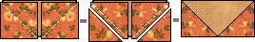 | To make one flying geese unit, place a Color 1 square right sides together atop a Color 3 rectangle, with outer edges aligned. On the back of the top square lightly mark the diagonal. Sew on this diagonal marking. Cut off the excess seam allowance. Press the remainder towards the corner. Repeat this with another Color 1 square on the other end of the rectangle. Make four of these...

 | 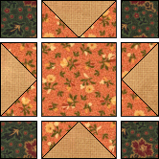 | Now lay out all units as shown at left. Sew three horizontal rows, pressing the top and bottom row seams to the center, and the middle row seam to the outside. Sew the rows together and there is your Austin block!...on to Page 2!

Austin - Page 2

 | 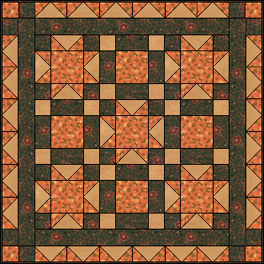 | Here are five Austin blocks alternated with uneven nine patch blocks!  Happy Quilting Folks!  Marcia :o)  Page 1  Here's Michele's! Karlene's!  Jeanette's! Melissa's!

** Supplies List **

 | Color 1 | Color 1 needs: one 6-1/2" square AND one 7" x 14" strip

 | Color 2 | Color 2 needs: one 3-1/2" x 14" strip

 | Color 3 | Color 3 needs: one 3-1/2" x 26" strip

