Source: http://www.sewvacdirect.com/

Juki TL98Q
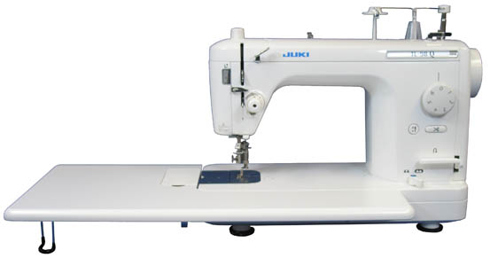
Factory Serviced High Speed Sewing and Quilting Machine with Bonus 100 Needles

The Juki TL98Q is a Single Needle, Lockstitch Machine for straight stitching and quilting, is also perfect for tailoring, dressmaking and home decor items. The Juki TL98Q can be used as a table top machine, mounted into some cabinets or used on machine quilting frames. It is portable and has a built in carrying handle. Sewing area extension shown in picture is included with the machine.

Features

* Two Types of Quilting Foot / Drop Feed Two types of quilting feet are supplied as standard accessories with the machine. A 1/5 Quilting Foot is used for basic quilting and the Quilting Foot for precision sewing with 1/4" inch stitch width. The feed dog can be raised and lowered simply by depressing a switch. When quilting, the drop feed allows you to sew curved stitches with ease.
* Even Feed Foot With its reliable feed, the even feed foot ensures the machine's ability to produce beautiful seams when sewing difficult-to-feed fabrics such as georgette and velvet, as well as heavy weight materials such as leather.
* Automatic Thread Trimmer The machine is equipped with an automatic thread trimming device that simultaneously cuts the needle and bobbin threads at the sewing end by lightly pressing the push-button. It uses the thread trimming mechanism that is similar to the industrial sewing machine type.
* Foot Pedal Switch for Thread Trimming As with an industrial sewing machine, the thread trimmer can be activated with the foot pedal switch. It greatly increases sewing efficiency.
* Easy Bobbin Replacement A new bobbin case latch and an enlarged bobbin case area make it easier to remove and replace the bobbin.
* Automatic Needle Threader The push lever automatic needle threader easily threads the needle without eyestrain and allows you to start sewing quickly.
* Knee Lifter Lever The knee lifter lever allows you to lift / lower the presser foot without using your hands.
* Adjustment of Presser Foot Pressure Presser foot pressure can be adjusted according to the fabric being sewn by turning a regulator located on the top of the machine.
* Extended Sewing Area The throat size from the needle to inside the machine is 8.5 inches.

Additional Features

* Sews heavy weight materials with ease
* Predetermined stop position of the needle
* 1/4 foot and free action foot
* Adjustment of pressing pressure according to material weight
* Thread tension scale
* Automatic stop-bobbin winding
* Portable sewing machine
* Automatic thread trimmer
* For tailoring, quilting, dressmaking, and many other applications
* 1500 stitches per minute
* Stitch length 6 mm
* Universal presser foot tape ribbon narrow elastic application
* Presser foot lift 7 mm by hand
* Knee lifter 12 mm extra lift
* Throat Area: 8.5 (L) x 5.9 (H) inches
* Auxiliary table included: dimensions 590 mm x 277 mm (12 x 23)
* UL Listed
* Includes the Following Accessories: Walking Foot, Darning/Embroidery Foot (Also called "Free Motion" Foot), 1/4" Seam Foot, Rolled Hem Foot, Zipper Foot, Instruction Manual, Electronic Foot Control
* Manufacturer's Warranty - 5 Years Mechanical, 2 Years Electrical, and 90 Days Labor

Regular Price: $1,499.99
Your Price: $799.00 Free ground shipping in the contiguous US!

###
captured 9/13/07jk

