Maple Leaf Mug Rug
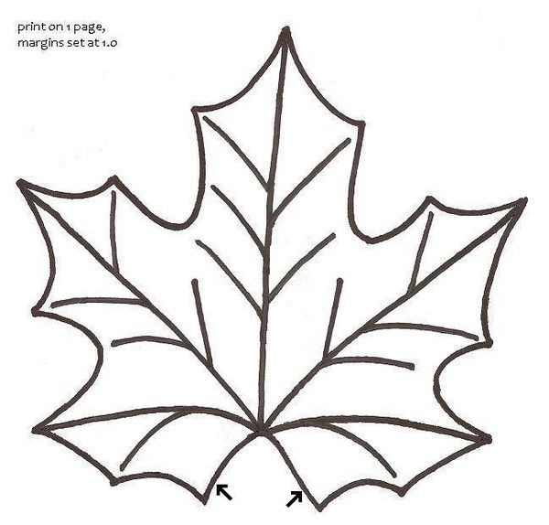

2. Choose your fabric (or fabrics) and make a layered sandwich in this order: Bottom - Quilt batting / Middle - fabric square, face up / Top - fabric square, face down.
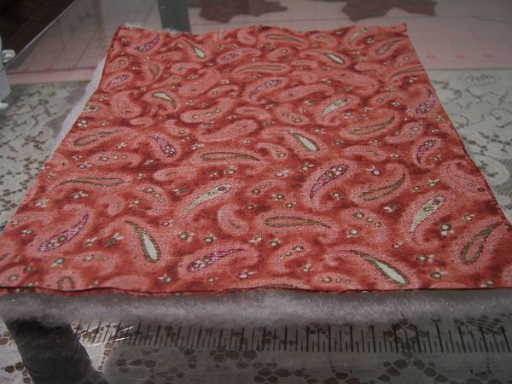

3. Pin the Pattern to the top layer of fabric.
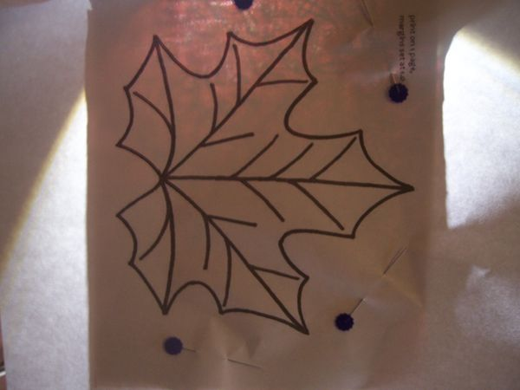

4. Set your sewing machine for a very small straight stitch. Sew around the outside edge of the leaf pattern, starting and stopping at the arrows on the pattern. Reinforce the first and last corners with backstitching along the way.
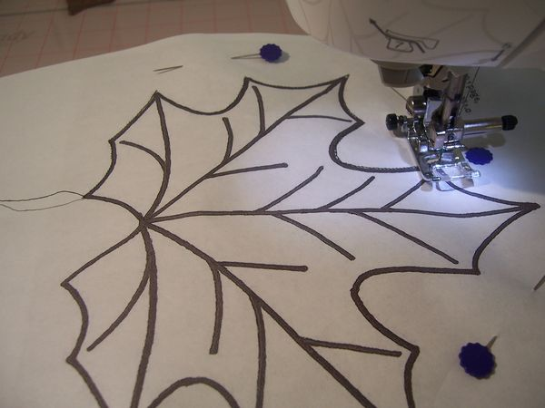

5. Trim the batting very close to the outside of the stitching, including the v-shaped indent at the base of the leaf pattern.
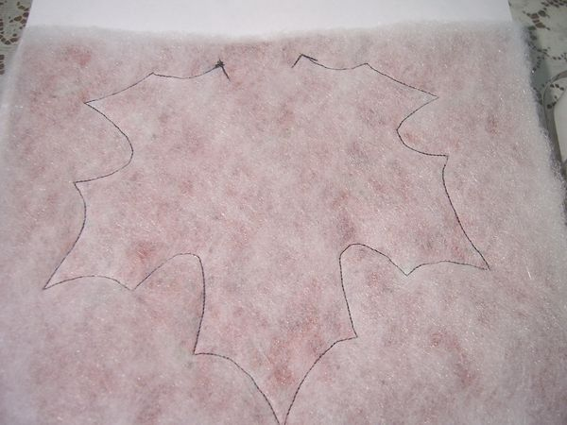
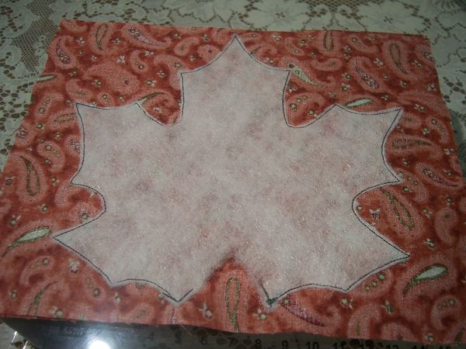

6. Flip the leaf over. Pull off the paper around the Outside of the leaf. Leave on the paper within the leaf pattern. Keeping it in place will help you to see the stitching line as you trim the fabric, especially if your thread matches your fabric.
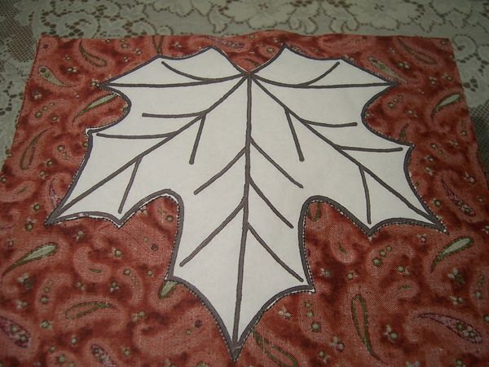

7. Cut away the excess fabric, leaving a 1/8 inch seam allowance.
*Please note: where the v- shaped opening is, it works better to leave a 1/4"
seam allowance and snip into the tip of the "V" as illustrated in the picture
below. This helps when it comes time to turn that edge under. Also, you can
coat each edge of the "V", top and bottom and seal them shut together, with
washable fabric glue, then when it dries, trim it nice and neat.
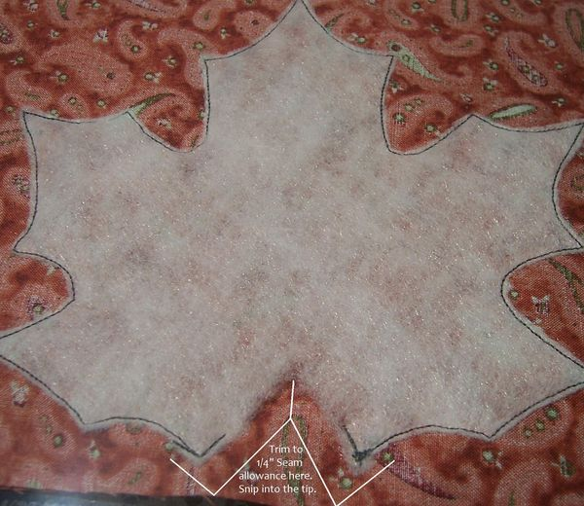

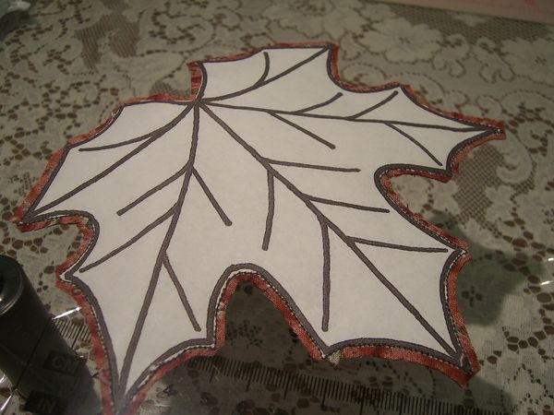

8. Trim the corners and clip the curves all around the outside edge of the leaf, being very careful not to cut into your stitching. (This is where leaving on the paper really helps!)
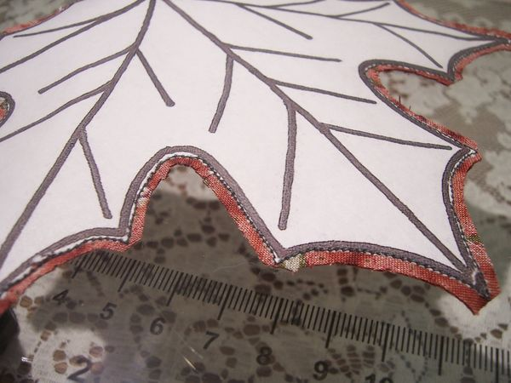
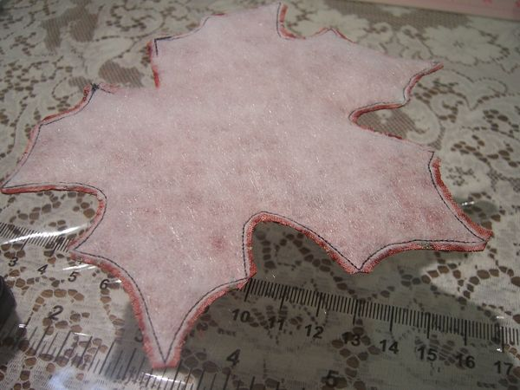

9. Now remove the paper leaf pattern carefully, keeping it whole for later use.
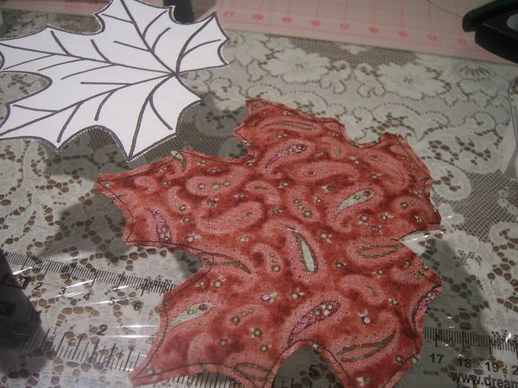

10. Turn your fabric leaf right side out.

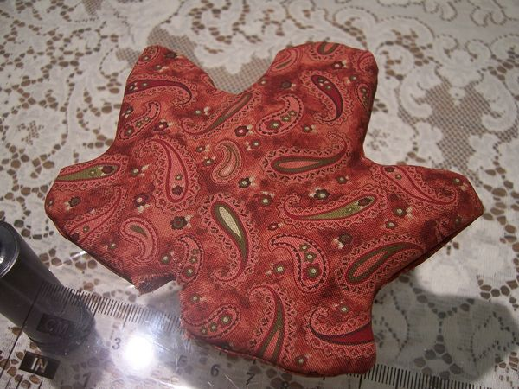

11. Very carefully work out the tips of the leaves to points and fill out the curves. I used a dull pencil to help me. Turn under the 1/8 inch allowances
at the opening. Now iron the leaf flat. Stitch along the opening to close it.
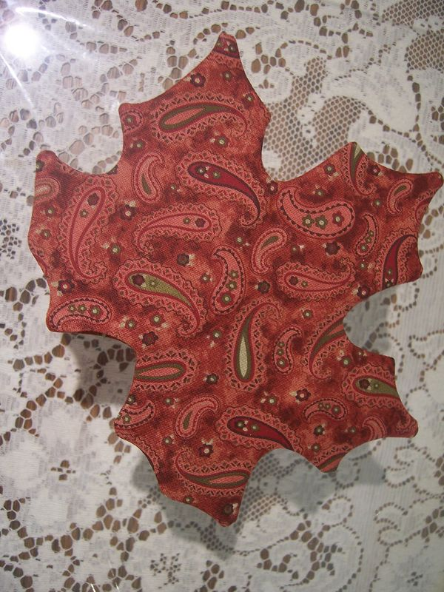

12. Pin the pattern back on the leaf, making sure to center and line it up. It will be a little large than your leaf, but that is okay as long as you take note of it and don’t run your machine off the edge of the fabric. Or, alternately you can trim the excess off the pattern.
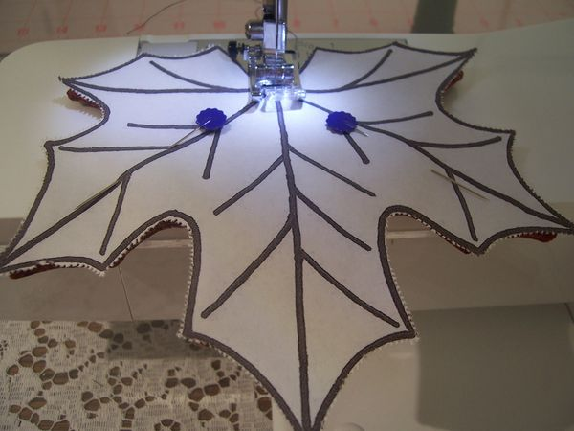

13. Stitch along the veins of the leaf in one long continuous line of stitching. I start by going straight up each center vein and then backtracking up and down each side vein on the way back down. Be careful to closely follow your own lines of stitching on the way back along them, so as not to leave small gaps for the paper to get stuck in. My presser foot was sometimes getting a bit stalled on the bulky leaf tips when I turned to head back down, so I used a pencil eraser to give the fabric a gentle push through. You could also simply stop your stitching before you reach the end point of the leaf.
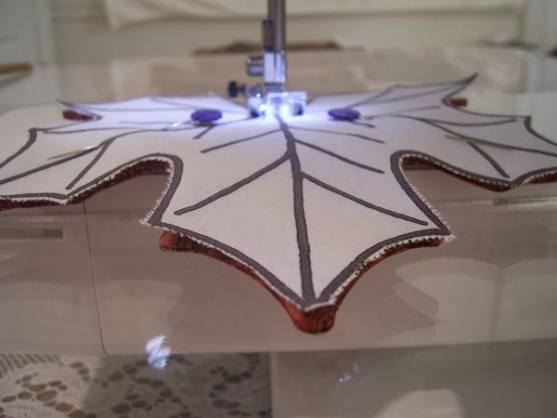

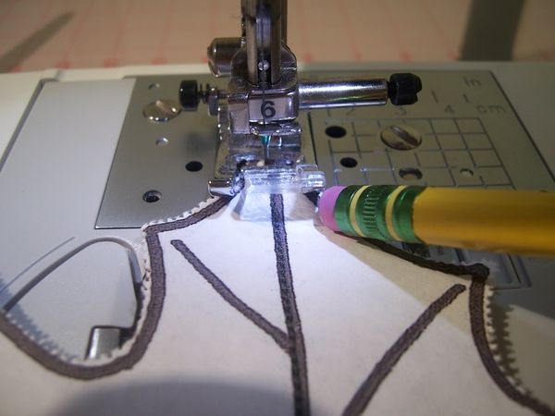

14. Remove the paper pattern. Use tweezers to get any little stuck bits of paper out.
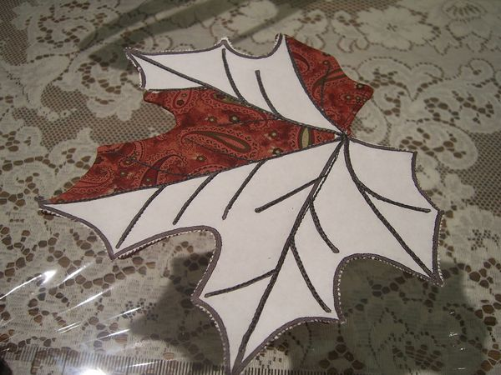

15. Your leaf is finished… Now go brew a cuppa and enjoy!

\