ANTIQUE LOG CABIN VARIATION
(As seen in http://www.quiltingboard.com/pictures-f5/my-ancestors-t184422.html)

This tutorial is a pattern for making the block as seen in the quilt above. It assumes the quilter knows at least some of the log cabin piecing technique, though here you will be chain piecing rather than cutting each log before piecing.

Red log strip is cut 2½” x width of fabric
All other log strips are cut 1½” x width of fabric

 Chain piece red log strip to one green log strip. Press seam toward the green strip.

Cut into 2½” segments. 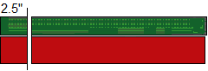

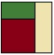 Chain piece above segments to one tan log strip. Cut between the segments and press away from red. Trim edges even with red/green segment.

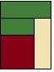 Chain piece above segments to one green log strip. Cut between the segments and press toward added log. Trim edges even with previous segment.

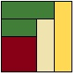 Chain piece above segments to one length of yellow log. Cut between them and press toward added log. Trim edges even with previous segment.

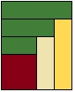 Chain piece above segments to one length of green log. Cut between them and press toward added log. Trim edges even with previous segment.

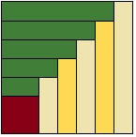 Continue to chain piece as above until you have added 5 green logs and 5 tan/yellow logs and your blocks look like this.

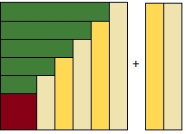 Sew a long tan log & a long yellow log together. Press toward the yellow.
Sew strip pair to the block. Trim even with the block edges to create this:

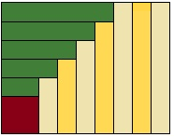
 Sew 2 long green strips together.
Chain sew red squares to the long green pair. Cut between them. Press away from the red.
Trim even with strip edges to create this: 

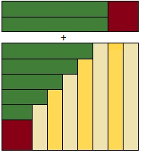 Sew the red/green segment to the block. Press away from the red.

There’s your block! Make as many as you need for YOUR quilt!

