HEARTS FOR VALENTINE’S DAY 2012
Jan Bennett-Collier

The technique of “snowballing” is used in these hearts.
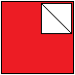 One snowball square is layered right sides together, raw edges even, with the base block segment. Sew across the diagonal as shown here by drawn line. Press toward the corner to create a triangle on the corner of the base block segment. *TIP: IF you are not handquilting, cut out only the middle layer of this triangle, because the red corner is helpful for aligning this segment to the next segment when sewing the block together.*

The following two hearts are designed to be set on point. Or they can be straight-set and left to recline on their side for different look. If you need information for setting quilts on-point I have a tutorial on the board for doing that with ease; or I can send it to your regular email address. (janbencol@aol.com)

FIVE INCH BLOCK:
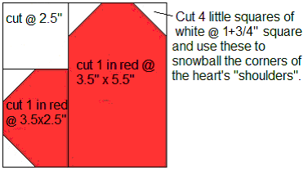

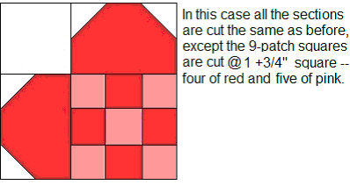

These hearts’ size can be adjusted but they are best proportioned in a 2 to 3 ratio. Figure the “shoulder” segment first – here they are 2” wide by 3” long. This makes a 5” block, which is an attractive size for these hearts, even in a border. (Or the block could be 7.5” square with 3” x 4.5” shoulders.)
I urge you to draw them out on 4-to-the-inch graph paper to be sure your heart is a pleasingly rounded shape with adequate “cleavage” at the inward point of the “shoulders”.
The following heart is designed to be straight-set in the quilt, whereas the ones above are designed to be used on point.

SEVEN INCH BLOCK:

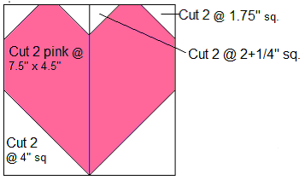

This heart can also be adjusted from the 7” block figured here. Note that the two inner “cleavage” snowball squares are slightly smaller than the outer “shoulders” snowball squares. To my eye this makes for a more pleasingly rounded shape of heart.

