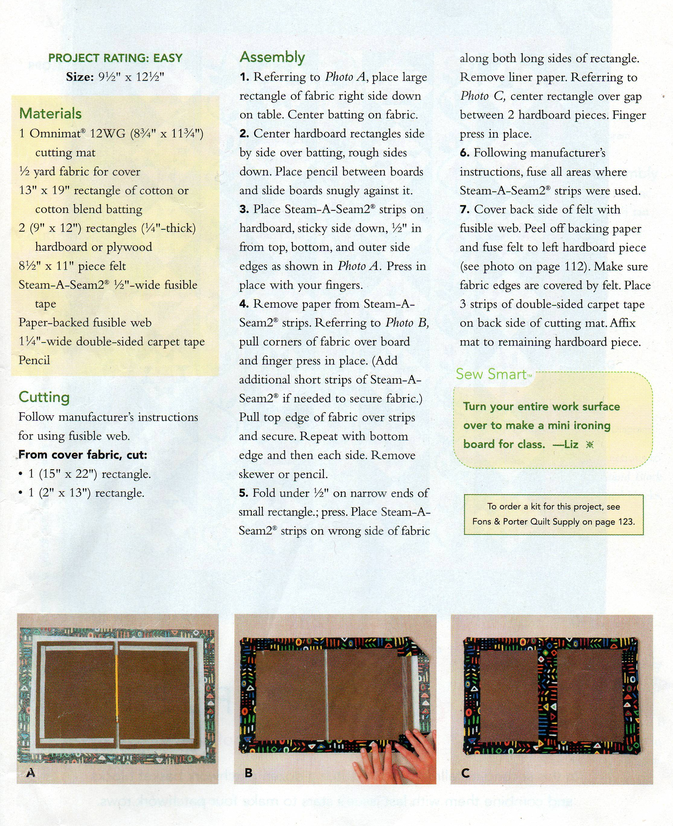

Top Tip
Make a fitted cotton cover, from a pillowcase.

That way you don’t scorch the cover and it’s washable!

