I create custom memory and t-shirt quilts. Every stitch is made with care and attention to detail in the traditional style of quilting three layers together. Made with your t-shirts, these one of a kind quilts will allow you to enjoy all of your favourite t-shirts in a brand new way.

All quilts are designed and created in my smoke free and pet free studio in Ontario, Canada. These beautiful quilts can be machine washed gentle cycle cold water and tumbled dry low gentle setting or line dry.

***TERMS***
A $100.00 deposit is required to start your quilt. The $100 deposit will come out of the final costs the final price. The balance will be due when the quilt is completed.

Mail your freshly washed, uncut t-shirts (do not use fabric softener) to me. Make sure they have no holes or tears. Very worn shirts will shorten the life of your quilt so it is important the shirts you choose are in good condition. I will create quilt blocks out of your shirts and create a one of a kind quilt for you to cherish for years to come.

As soon as I receive your deposit, shirts and get the fabric choice you desire, I will provide you an estimated finish date.

Once I receive the balance I will mail off your one of a kind memory quilt. I will send you confirmation of return shipping as well as a tracking number.

***PRICING***
The listed prices cover all material (including the fabric for 2 inch sashing and 2 inch borders, backing, 1 inch binding, batting, thread) and labour.

All quilts are $15.00 per shirt. Add $3.00 per shirt if you want to add sashing.
Sashing and backing can be your choice of color. Include any preferences with your t-shirt shipment to me.
Shirt sizes are based on 15" squares. I will do any number of shirts that you like.
Without Sashing With Sashing Square Layout
9 shirts = $135.00 (51”x51”) $162.00 (55”x55”) 3x3
12 shirts = $180.00 (51”x66”) $216.00 (55”x72”) 3x4
16 shirts = $240.00 (66”x66”) $288.00 (72”x72”) 4x4
20 shirts = $300.00 (66”x81”) $360.00 (72”x89”) 4x5
30 shirts = $450.00 (81”x96”) $480.00 (89”x106”) 5x6
42 shirts = $630.00 (96”x111”) $756.00 (106”x123”) 6x7

The cost of shipping will be added to all orders.

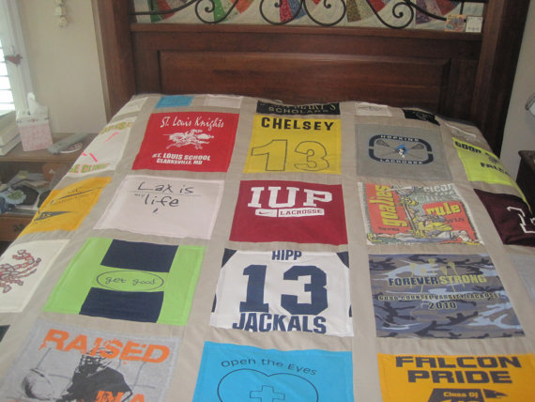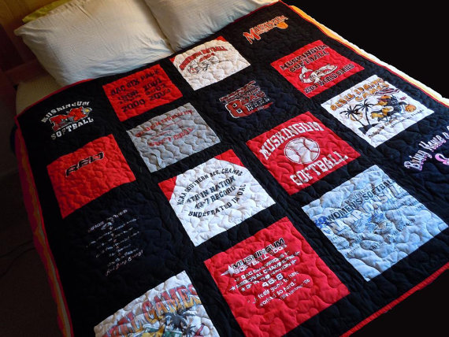

Options: With Sashing

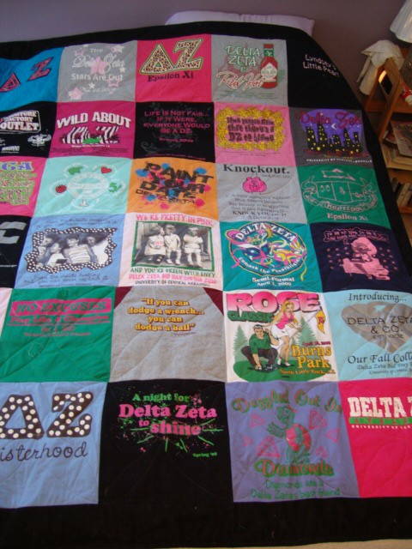

Option: Without Sashing

