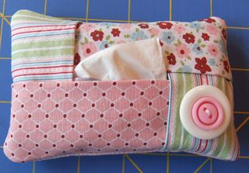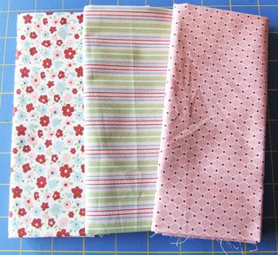
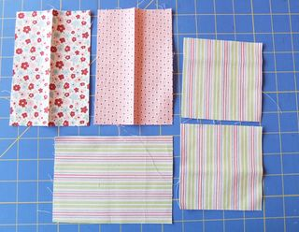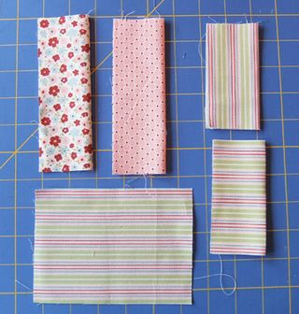
. Start by cutting 5 pieces of fabric---3 pieces @ 4" x 5 3/4"----2 pieces @ 4" x 4"
4th Picture: Fold 4 pieces in half. These are the flaps on the front of the Kleenex holder.
Leave one large piece flat. This is the back of your tissue holder

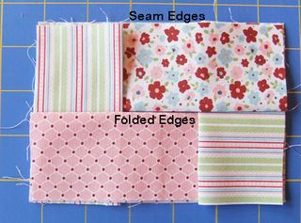 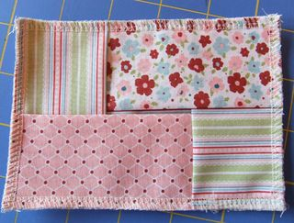 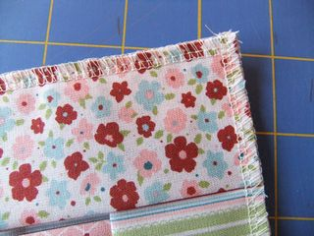
Since you are working on the inside of the project and you want all your seams on the inside, you must lay the 4" x 5 3/4" face up (pretty side up) to start. Then layer the folded pieces of fabric on top of the flat piece. Layer the fabric like a folding the lid of a box. Be sure to place the folded edge of the fabric so that lays toward the middle and NOT on the seam edge. Pin all your edges in place.--Sew a seam all around the outer edge of the the pouch.
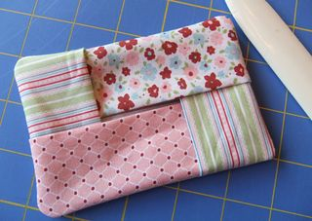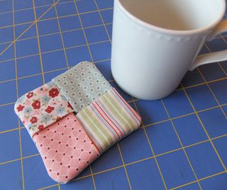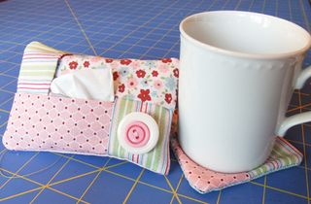
Turn your little creation inside out and viola! you have a Kleenex pouch. Stuff your Kleenex package in the pocket and embellish the outside any way you want. I used a bone folder to push out the corners from the inside.
Now that you've made a Kleenex pouch, try making a drink coaster the same way.----Cut 5 pieces of fabric @ 5" x 5" and complete it the same way that you made the pouch..
(As a footnote, this coaster was cut 4" x 4" which in hind site is too small. I'll definitely cut it the larger size next time because you lose about 3/4" when you sew the seams.)

