QAYG (Quilt As You Go) Tutorial
Please note this is my very first tutorial, so if the quilting police are on my heels, please wait until the end to arrest me as I have promised a few folks I would post my method. Note that I do not take credit for these ideas, I’ve visited many websites and blogs that offer QAYG info and I can assure you I have nothing I can claim as original. I take pieces parts and put them together to find something that works for me. Long arm services are a tad out of my price range at the moment so QAYG helps my ϑwallet until my daughter is out of school
First off, piece your squares. I tend to like big squares so I have worked with squares up to 21” and with rectangles up to 21” x 110”. You can use any style squares but just know that you will have joints showing on your top and back although you can get creative with fabric choices for your joints so that they blend in pretty well. After you have pieced all your squares, cut a backing fabric piece and a batting piece for each one. I like to cut mine just a tad larger than my pieced square to give me some wiggle room, a scant ¼” extra batting and backing on each side works for me. Attach the 3 layers using your favorite method (I use either 505 basting spray or fusible batting by Hobbs), I’m not patient enough to pin but that is certainly an option. Now it’s time to quilt. Whether it’s free motion, stitch-in-the-ditch, stenciling, etc. you can do whatever you like. After quilting your blocks its time to square up (or rectangle up if you’ve chosen that shape). Square the batting & backing fabric as close to the top fabric edge as possible, keeping in mind you will be using ¼” seam allowance when you add the joints. (Find what looks to be your smallest block of the bunch and use that one block size as your target finished block size). After squaring you should now have a nice neat stack of quilted blocks ready to go. (Im just using some practice quilt sandwiches I made, the quilting will hurt your eyes, DONT LOOK
Attaching the joints: I have done it 2 different ways, they are very similar though. I’ll reference them as method A and method B.
Method A: You will need to cut strips of your choice of fabric 1 ¼” wide for the top of your block and 1 ¼” wide for the back. With a hot iron, take the top side strips and fold down ¼” and press the entire length of the strip. How many inches of strips you need will depend on your block size and on your target finished quilt size. You will need strips between each block to make rows, then you will need strips between each of those rows.
Method B: You will need to cut strips 1 ¼” wide for the top and 1 ½” for the back. With a hot iron, take the back side strips and fold each long edge to the middle and press so that you end up with a strip that has the raw edge pressed to the middle from each side. See above for info on how many inches of strips you will need.
Using method A strips: on your machine bed place a backing strip, which is the strip that DOES NOT have the crease ironed in (“pretty” side up), quilted block (back side down), top strip (with the crease ironed) raw edge to the edge of the block (pretty side down), you will end up with a 3 part stack. Sew the 3 pieces together using a slightly generous ¼” seam the entire length of the block. Lift up the block and slide in underneath it your adjoining block (backside up). Line up your edges and sew using the generous ¼” seam. Now flip open your blocks that are now joined and you should see that your batting from each piece is now fitting snuggly together. Fold over your top strip and stitch in place the length of your block. You now have your first 2 blocks welded together. If you like, you can also straight stitch down the other side of the joint so that both edges look the same.
Using method B strips: on your machine bed place a quilted block (pretty side up) and a top strip (no crease ironed in) (pretty side down), stitch all the way down theb lock with slightly generous ¼” seam. Now flip this unit over (pretty side of the block down) and line the joint raw edge up with the edge of the pretty side of your next block (your blocks should be pretty side to pretty side) and sew again using generous ¼”. Now flip the bottom piece out and you will see your two batting pieces nesting together. Grab some water soluble glue and apply dots all along the top of your seam allowances on both sides, press in place your backing joint strip (the one that was pressed with two creases) so that it completely covers the joint. I run a hot iron down the strip to help set the glue. You can then flip over your unit to the right side and straight stitch down the joint from the front. I either stitch in the ditch or use 1/8 into the strip. Using this method you can actually wait until you have joined all your blocks in the front and then focus on getting the back strips on. I’ve found that doing the back using “length and width of the quilt strips” goes really fast. Just lay down all the joints going one direction and glue baste, then lay down all the joints going in the other direction and glue baste those. I don’t even cut the joint strips at the “crossroads”, just lay them over each other and once they are stitched they look fine.
Sorry its so lengthy (and probably confusing). Hopefully the photos will help a bit.
ϑOk, the quilt police can now read me my rights..
Pieced block with batting & backing fabric
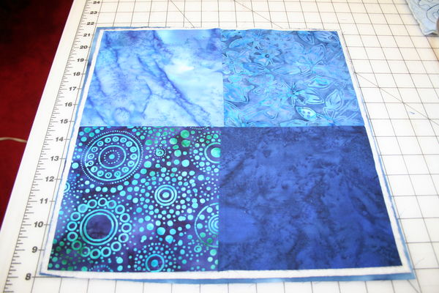
pieced block with really bad quilting squared up
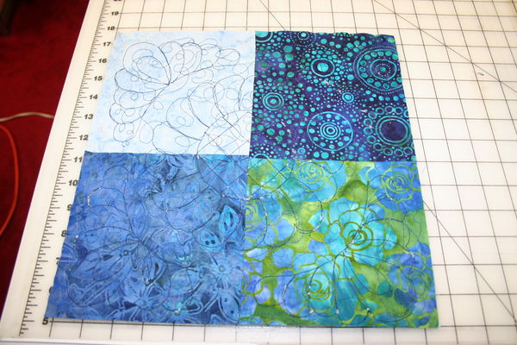
Close up of trimming
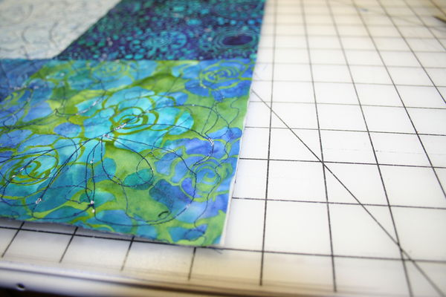
Method A on left, method B on right
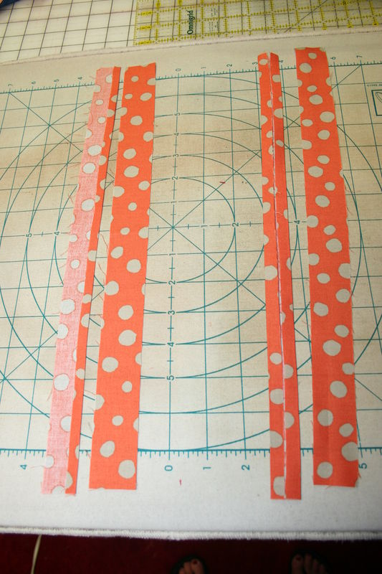
Closeup of A
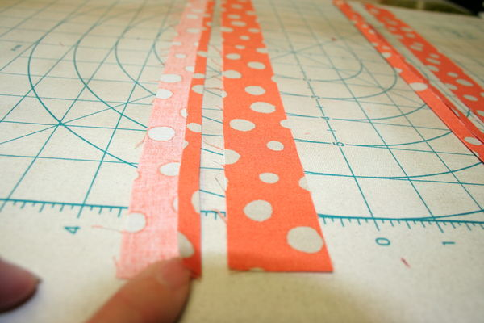
Closeup of B
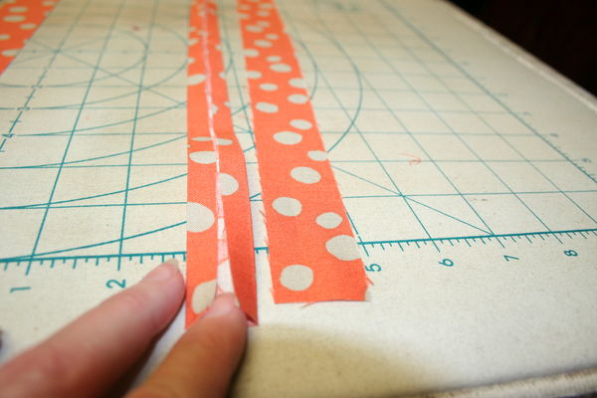
Method A triple layer
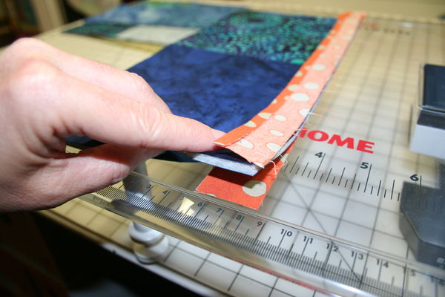
Triple layers sewn together
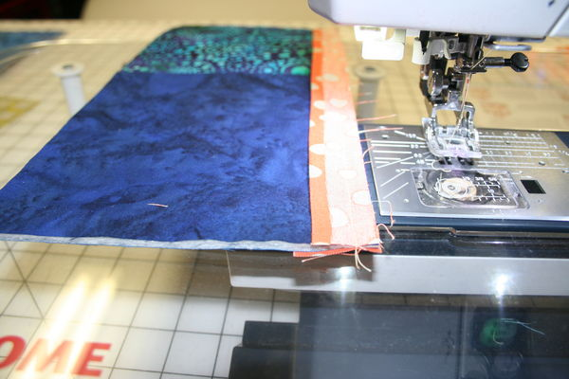
Slide additional block under and stitch
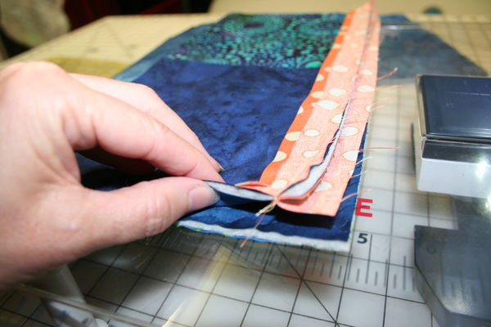
Now flip open your blocks and see how they nest together.
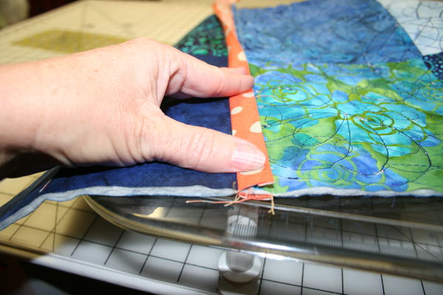
Top stitch down the length of the strip, and down the other side if you want,
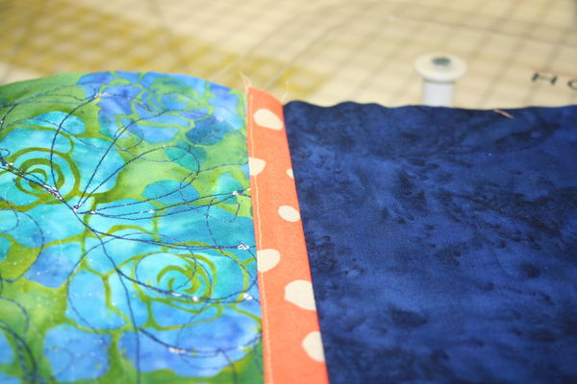
The back after attaching by way of method A, tah dah !!!
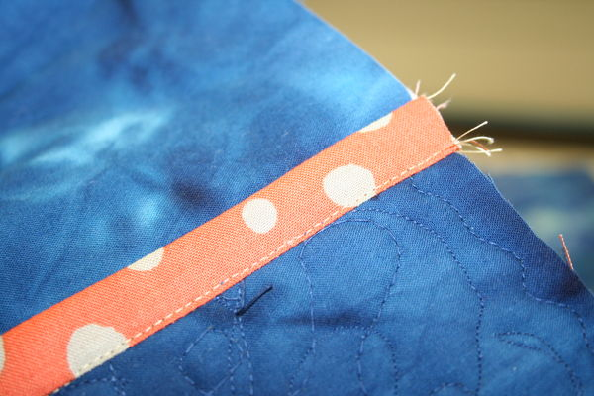
Alignment for method B
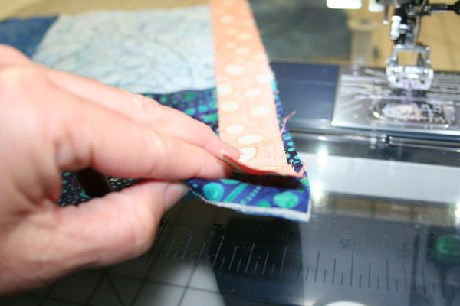
2nd block added, stitch all the way down
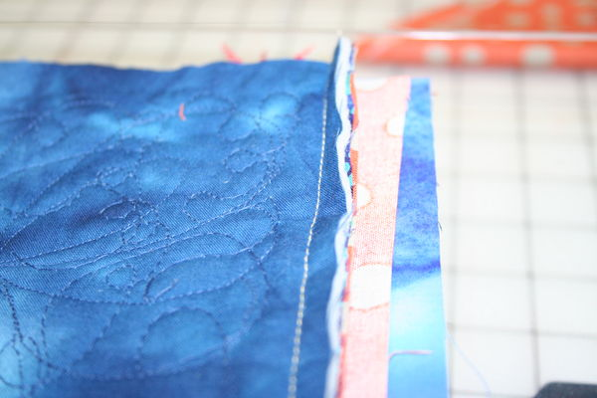
Close up of adding 2nd block
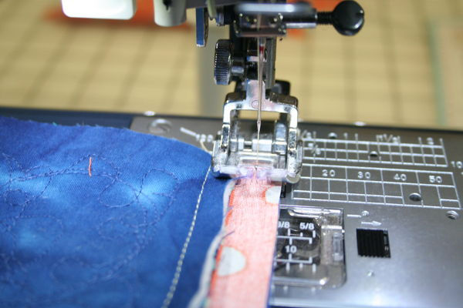
Flip open the 2 blocks, see how the batting is now nested
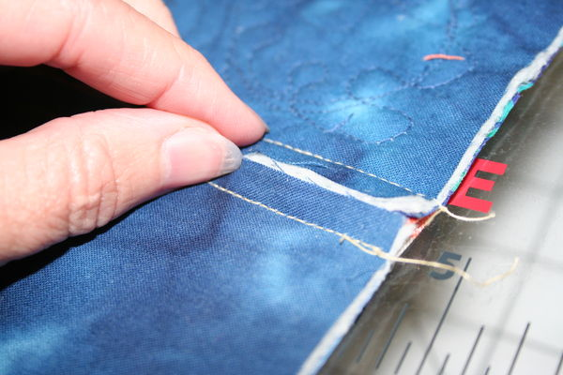
If you wish you can run a hot iron over the joint to flatten
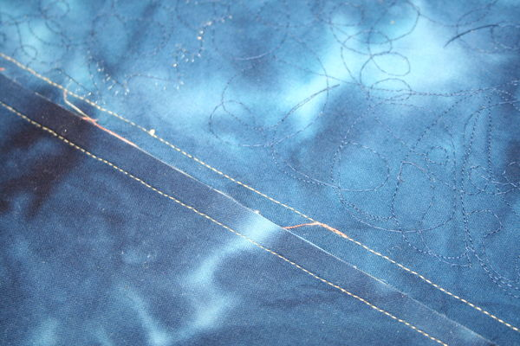
Grab your school glue
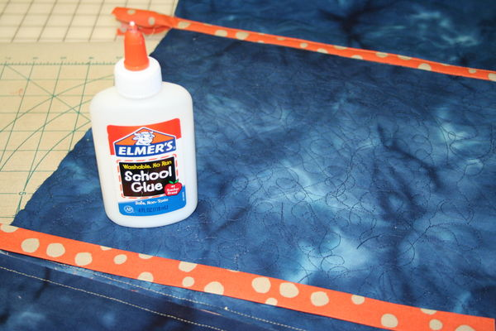
Little dots of glue all the way down
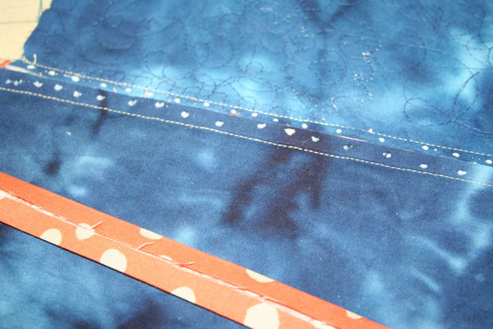
Run a hot iron over the joint
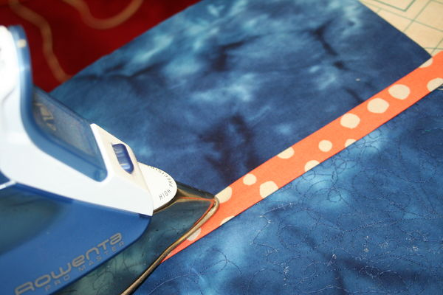
Flip piece over and top stitch from the front.
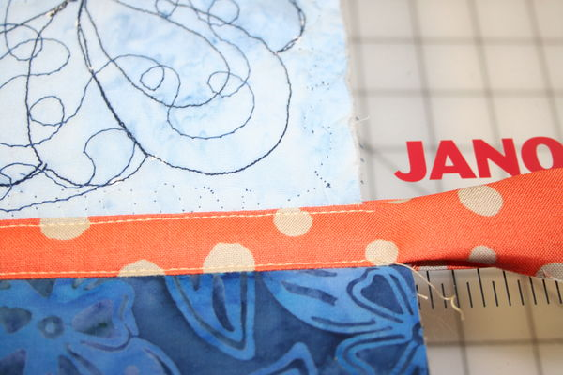
Thats it, method B is done. Its hard to tell from the front which is which.
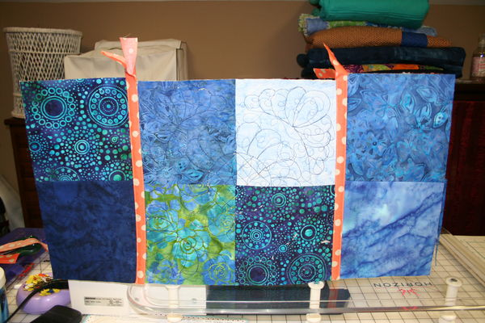
On the back Method B on the left the joint is a little wider (thats because you are sewing blindly from the front and I like to give myself a little more surface area on the joint.
