A Patriotic Union Quilt
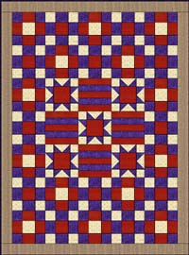
Stars were among the earliest pieced patterns in America so they had been used on patriotic quilts long before the Civil War. In this quilt I used The Variable Star to symbolize the patriotism of Union quilters. Along with the red and blue bars this quilt represents the American flag. I was inspired to use this configuration for a quilt after viewing a Civil War quilt in the New England Quilt Museum.

The Bonnie Blue in a Confederate Quilt
Hurrah! Hurrah! For Southern rights hurrah!
Hurrah for the Bonnie Blue Flag that bears a single star.
by Harry Macarthy
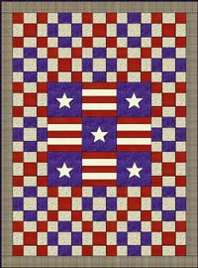
When Mississippi seceded from the Union a blue flag with a single white star was raised over the capital building. One onlooker was so inspired he wrote the song, "The Bonnie Blue Flag", that became one of the most popular songs of the Confederacy. Although this flag never became the official flag it is one that represents the high spirits of Secession. I designed the confederate quilt with this flag in mind.
Shortly after the Civil War began the South adopted the Stars and Bars Flag. This flag had three horizontal bars, two red and one white. The upper left had a blue square with a circle of stars, one for each state that seceded. In the quilt pattern I used red and white bars to represent this flag.
Cutting Instructions the 10 Inch Blocks
The cutting instructions for the nine patch blocks that surround the center. You will have to decide how many of these you need to make depending on how large you want to make your quilt.
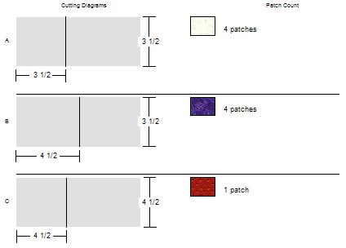
The cutting instructions for the bars.
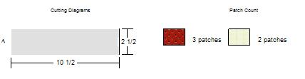
The PDF for the Confederate appliqued star template is here. Be sure to set the page scaling at "none" before you print so the star will come out the right size. Cut the background about 12 inches and applique the star to the middle. Then trim to 10 1/2 inches.
The cutting and sewing instructions for the Variable Star block.
