From United to Divided
The symbol that united the nation after the War of Independence came back in the mid nineteenth century as a symbol representing the division between Confederate and Union. This quilt pattern is definitely a quilt that would have been made in the North.
The Center With Appliqued Eagle
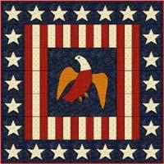
Cut your blue square to 20 or more inches. You will trim it later to fit with the flag stripe blocks.
Open the Eagle Template PDF for the applique pattern. Be sure you have set Page Scaling to "none" before you print so that the templates will be the right size.
You can applique the eagle using either hand stitching methods or modern fusible methods.
For hand applique methods go to McCall's Quiltmaking Fundamentals and for machine applique you will find instructions at McCall's Quilting: fusible Machine Appliqué.
The Flag Strips Surrounding the Eagle Center
Below are cutting instructions for the red and white flag stripes background which is made up of a series of 6" blocks that surround the central eagle.
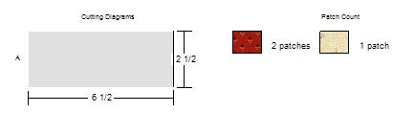
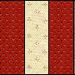 make 12 blocks 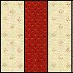 make 4 blocks

When sewing together the top and bottom blocks note that you alternate with a red/white/red block on each end. Sew them together then sew the three vertical blocks of ed/white/red. Measure them carefully as you will trim your eagle center to that size.
Finish With the Star Border
I find it's easiest to cut out 6 1/2 inch squares then applique a star in the center of each square. Go to the Star PDF Template for the applique pattern. You will need 24 of these. Sew them together and apply them to the quilt as the border.
A Confederate Version
If you are a Confederate Civil War reenactor might wonder what the South's counterpart was. The symbol I found was that of the pelican though it was not so widely used by the South as the eagle was in the North. The pelican has been a symbol for Louisiana since the early 1800s so when Louisiana seceded from the Union a blue Pelican Flag was raised. There are references in history to everything from the Pelican Battery, a volunteer artillery unit, to pelican buttons worn on Confederate soldier's uniforms.
You can find a pattern for a Southern Secession quilt with a pelican downing an eagle at Terry Clothier Thompson - Civil War Quilts. Another possibility would be to draw a simplified pelican that could be done in applique. It could be put on a blue background much like I've done with the eagle.

