FAST FLYING GEESE
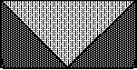

You will need one large square and four small squares and that will make 2 flying geese units. 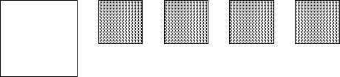
Place 2 contrast print squares on opposite corners of the large square.
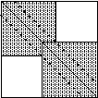
Draw align diagonally from corner to corner and then sew 1/4" on each side of the line. Cut along the drawn line and press the triangles to the outside.
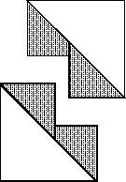
For each of these units place another square on the remaining corner of the large triangle.
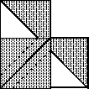
Draw a diagonal line on the small square and sew 1/4" of each side of the line. Cut on the drawn line and press. Square up if necessary.
FAST FLYING GEESE
SIZE OF FINISHED UNIT | LARGE SQUARE | CUT FOUR SMALL SQ
8" X 4" | 9 1/4" | 4 7/8"
7" X 3.5" | 8 1/4" | 4 3/8"
6" X 3" | 7 1/4" | 3 7/8"
5" X 2.5" | 6 1/4" | 3 3/8"
4" X 2" | 5 1/4" | 2 7/8'
3" X 1.5" | 4 1/4" | 2 3/8'
2" X 1" | 3 1/4" | 1 7/8"

