
Dear Friends,
It was such a great deal that we couldn’t pass it up! We just raised our hand and bought every roll! Now, it has been delivered and our warehouse is literally full to the rafters.
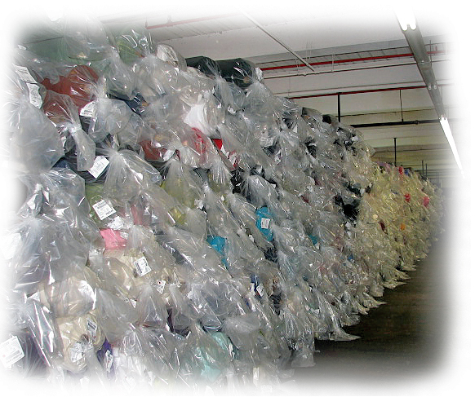
We must either rent more space
or pass along great savings
and get this stuff out of here!
In other words, we have acquired an extremely large variety of genuine Polartec®, made in U.S.A, full roll products, that we are able to pass along at unheard of prices. This is the same brand and products that we usually wholesale, but at a ridiculously low cost per yard! If you stock full rolls of Polartec® fleece, and you are able to take advantage of this windfall purchase, then read on and save yourself a bundle of bucks!
PLEASE NOTE: This is a FULL ROLL sale only. Sale products are limited to those listed. Rain checks are not possible. This pricing is being offered to thousands of our customers world wide. Many products will sell out quickly. Our website does not update in real time, therefore, during high volume selling, it may show some depleted products. Expect slower shipping during the sale due to increased workload. Sale rolls can not be cut. Identical rolls of slightly different length (~15%) may be substituted. Sale ends Wednesday, June 30, 2010 at midnight.
There are over seventy full roll products on sale. If we were to include a picture of each product, this mailer would far exceed our maximum size. Instead, we have provided descriptions with “click on” links to the products main pages. Just click on the sale price to order or for full details.
Please enjoy shopping and $aving!

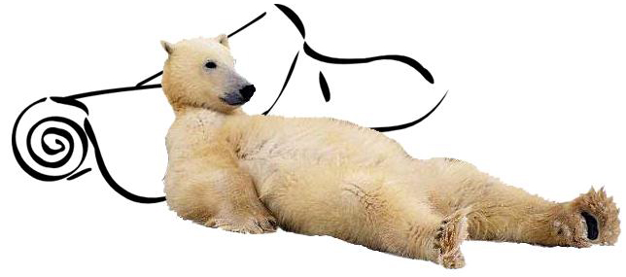

SERIES 100
COLOR NAME | FABRIC NAME | QUALITY | PRICE/YARD | SALE PRICE
Tim Horton Biege | Micro | First | $5.29 | $3.99
Hyacinth | Micro | Second | $3.70 | $2.99
Blue | Micro | Second | $3.70 | $2.99
Black | Check | Second | $3.70 | $2.99
Black | Double Velour | Second | $3.70 | $2.99
Amalfi | Tweed | Second | $3.70 | $2.99
Thunder | Tweed | Second | $3.70 | $2.99
Autumn | Tweed | Second | $3.70 | $2.99
Natural | Lt. Wt. Micro Rec | First | $5.20 | $4.99
SERIES 200
COLOR NAME | FABRIC NAME | QUALITY | PRICE/YARD | SALE PRICE
Muster | VLR DWR HTHR | Second | $5.15 | $3.99
Pflaume | VLR DWR HTHR | Second | $5.15 | $3.99
Onyx | VLR DWR HTHR | Second | $5.15 | $3.99
Pacific Blue | Micro With Stretch | Second | $5.15 | $3.99
Bright Navy | Micro With Stretch | Second | $5.15 | $3.99
Plum Berry | Micro With Stretch | Second | $5.15 | $3.99
Elderberry | Micro With Stretch | Second | $5.15 | $3.99
Onyx | Heather | First | $6.20 | $4.99
SERIES 300
COLOR NAME | FABRIC NAME | QUALITY | PRICE/YARD | SALE PRICE
Military | Shearling | Second | $4.95 | $3.49
Mudstone | Velour/Shearling | Second | $4.95 | $3.99
Anthracite | Velour/Shearling | Second | $4.95 | $3.99
Deep Water Blue | Double Velour REC | First | $7.20 | $5.75
Navy | Double Velour REC | Second | $4.95 | $3.49
Denim Blue | Double Velour REC | First | $7.20 | $4.99
Guava Green | Double Velour REC | First | $7.20 | $4.49
Denim Blue | Overdye Hthr REC | Second | $4.95 | $2.99
Dune Beige/White | Overdye Hthr REC | Second | $4.95 | $2.99
Dune Beige/White | Overdye Hthr REC | First | $7.20 | $4.99
White/Tungsten | Overdye Hthr REC | First | $7.20 | $4.99
White/Tungsten | Overdye Hthr REC | Second | $4.95< | $2.99
Charcoal Heather | Overdye Hthr REC | Second | $4.95 | $2.99
POWER DRY
COLOR NAME | FABRIC NAME | QUALITY | PRICE/YARD | SALE PRICE
Black | Waffle Stitch | Second | $3.20 | $2.75
Navy | FWT W/Xstatic | Second | $3.20 | $2.75
Blue | Jersy/Grid Back | Second | $3.20 | $2.75
Red | Jersy/Grid Back | Second | $3.20 | $2.75
Boxwood | Mesh Solid OdorResist | Second | $3.20 | $2.75
Wild Flower/Violet | CrossDye Jersey/Grid | Second | $3.20 | $2.75
Black | MidWt Mesh | Second | $3.20 | $2.75
Ink | Jersey/Shearling | Second | $3.20 | $2.75
Army T-Shirt | Jersey/Shearling | Second | $3.20 | $2.75
Replacement Black | Jersey/Shearling | Second | $3.20 | $2.75
Foliage Green | Jersey/Shearling Grid | Second | $3.20 | $2.75
Sand | Jersey/Shearling Grid | Second | $3.20 | $2.75
POWER STRETCH
COLOR NAME | FABRIC NAME | QUALITY | PRICE/YARD | SALE PRICE
Camas | Poly-Nylon/Velour | First | $7.25 | $4.99
Violet | Poly-Nylon/Velour | Second | $5.50 | $3.49
Fuscia | Poly-Nylon/Velour | Second | $5.50 | $3.49
Aubergene | Poly-Nylon/Velour | Second | $5.50 | $3.49
Grey | Poly-Nylon/Velour | Second | $5.50 | $3.49
Dark Navy | Poly-Nylon/Velour W/DWR Solid | Second | $5.50 | $3.49
Blue/Minimaze | Poly Jersey/VIR W/Hardface | First | $7.25 | $3.99
Shady Grey | Poly Jersey/VIR W/Hardface | First | $7.25 | $3.99
Blue Star/Treads | Poly Jersey/VIR W/Hardface | Second | $5.50 | $2.99
Greenery/Treads | Poly Jersey/VIR W/Hardface | Second | $5.50 | $2.99
Intense Red | Poly Jersey/VIR W/Hardface | Second | $5.50 | $2.99
Black/Treads | Poly Jersey/VIR W/Hardface | Second | $5.50 | $3.99
WIND PRO
COLOR NAME | FABRIC NAME | QUALITY | PRICE/YARD | SALE PRICE
Blauer Navy | LtWeight Solid | Second | $5.70 | $4.49
Green Tea/Treads | Hard Face/Velour W/Stretch | First | $10.20 | $5.99
Grass/Treads | Hard Face/Velour W/Stretch | First | $10.20 | $5.99
Deep Loden/Treads | Hard Face/Velour W/Stretch | First | $10.20 | $5.99
Coyote/Treads | Hard Face/Velour W/Stretch | Second | $5.70 | $3.49
Eggplant/Treads | Hard Face/Velour W/Stretch | Second | $5.70 | $2.99
Bright Blue/Treads | Hard Face/Velour W/Stretch | First | $10.20 | $5.99
Blue/Treads | Hard Face/Velour W/Stretch | Second | $5.70 | $3.99
Ionian Sea/Treads | Hard Face/Velour W/Stretch | Second | $5.70 | $3.49
Ultramarine/Treads | Hard Face/Velour W/Stretch | First | $10.20 | $5.99
Seal/Treads | Hard Face/Velour W/Stretch | Second | $5.70 | $3.99
Cloud Blue | Rip Stop/Shearling | First | $10.20 | $5.99
TNF Red | Rip Stop/Shearling | Second | $5.70 | $2.99
Black | Rip Stop/Shearling | Second | $5.70 | $2.99
NYPD Blue | Rip Stop/Shearling | Second | $5.70 | $2.99
Spanish Moss/Treads | Hardface | First | $10.20 | $5.99
Night Violet/Treads | Hardface | First | $10.20 | $5.99
Black/Black | Hardface | Second | $5.70 | $2.99
Little Boy Blue | Hardface | Second | $5.70 | $2.99
Black | Low Velour High Loft | Second | $5.70 | $2.99
Glossary of Terms
We appreciate your business and hope that our sales and specials are helping to keep your costs in line during these challenging economic times. Thank you!
Sincerely,
Your Mill Direct Textiles Team
Visit Our Website
