TWINKIE
(Because it has a yummy center. fat free) This quilt measures 63 x 63.
As promised your first pattern for the 10 inch square exchange 2009-Tina Cline.
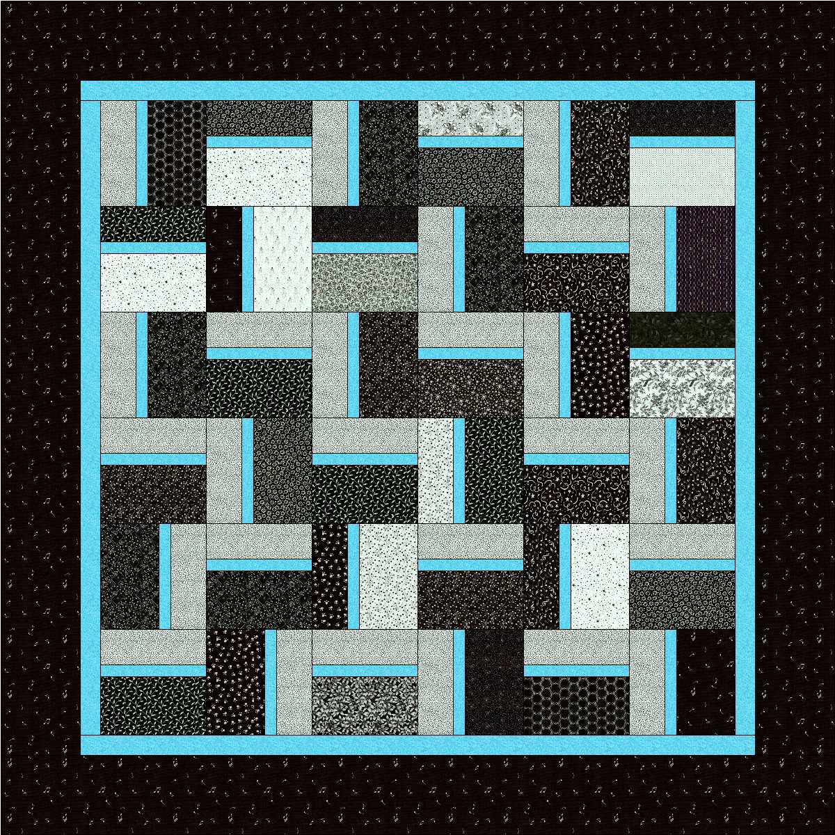

Supplies:
Thirty six 10 inch squares
1 yard of accent fabric for blocks and first border
1 3/4 yard for the 2nd border
1/2 yard for binding
The block measures 9 1/2 inches unfinished
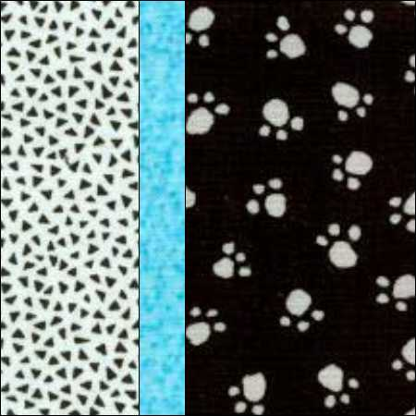
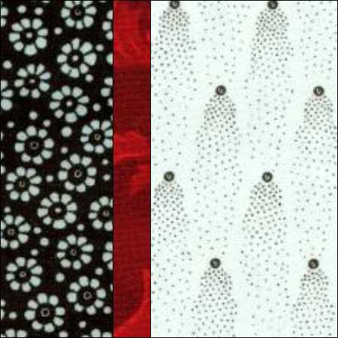
Shown both color ways.
Out of the thirty six blocks CUT each 10 inch block into two rectangles
5 1/2 x 9 1/2 rectangle
3 1/2 x 9 1/2 rectangle
You should have 36 of each size of rectangle

The accent fabric.
1st border is 1 1/2 inches wide. cut six strips length of fabric ( along selvage side)
Cut 36 strips of 1 1/2 x 9 1/2 for blocks.

2nd border is 6 inches wide
cut 6 inches wide the length of fabric along selvage.

Cut binding the width you prefer. My size is 2 1/4 inches wide
Cut 7 strips from width of fabric (selvage to selvage)

Sew blocks. Remember to mix up block color. Randomly sew blocks together. Arrange in a pleasing manner.
Quilt and bind as desired.

