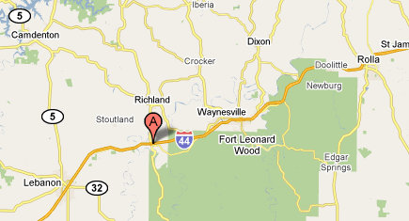
Quilted Oak
A Stitch in Time
&
The Fabric Store
Thread Peddler
Melear Fabrics
&
Uniquely Yours
Ozark Hills 6th Annual Shop Hop

