Starts Thursday, July 18th at 9:00 am
Ends Saturday, July 20th at 5:00 pm

Each quilter will receive 7 meals, lots of laughs, unending snacks and beverages, uninterrupted sewing time, and goodies to take home! Tables, chairs, irons, ironing boards and cutting mats will be provided. You are welcome to return home to sleep, get a hotel room, or for a small fee spend the night with us! Bring your own bedding and an air mattress or cot. The small fee will get you in a classroom at the church – a no frills, cheap section of floor with shower privileges. Roll away beds can be rented for $20 per night (must be prepaid). Don’t forget your towel and bedding!
The Stitched With Love Ministry
Of Wedgwood Baptist Church
Will Host Its
3rd Quilt-A-Thon
July 18-20, 2013
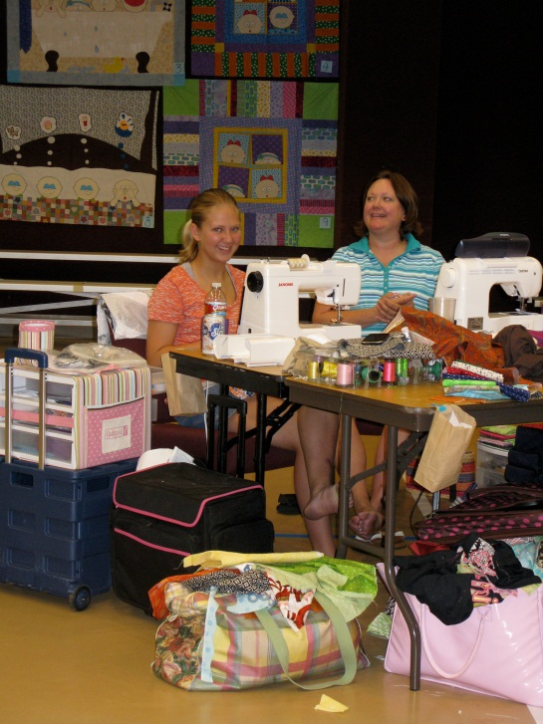

Come Join Us

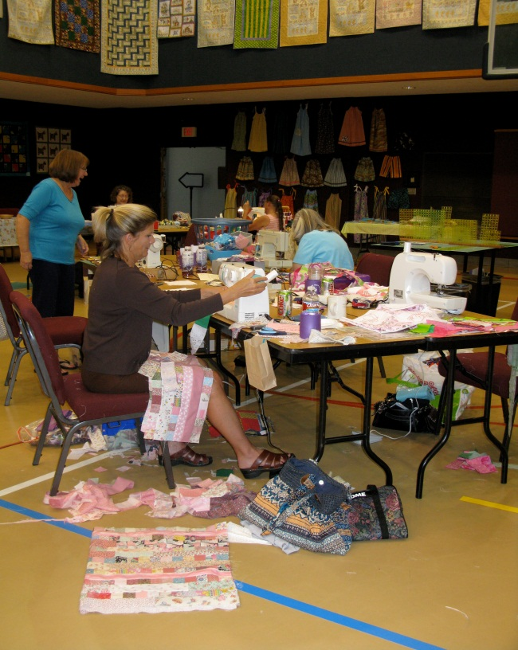
Cost

If staying all three days:
Registration Fee -- $75
Spend the Night Fee -- $20
Roll Away Bed Fee -- $40
If unable to stay all three days:
Registration Fee -- $30 per day
Spend the Night Fee -- $15 per night
Roll Away Bed Fee -- $20 per night

Places will not be held without
payment of the registration fee
(and roll away bed fee, if needed).
Registration fees will be accepted on a
first come, first serve basis.
Cancellations must be confirmed in
Writing before June 30th for 50% refund
of the registration fee.

Directions to
Wedgwood Baptist Church
5522 Whitman Avenue
Fort Worth, TX 76133

The Easiest Way
From I-20 (SW Loop 820), exit at McCart Avenue and travel south to the first traffic light, Walton Ave. Turn right and travel west on Walton. The church is on the corner of Whitman and Walton.

For the Adventurous Soul
From I-20 (SW Loop 820), exit at Granbury Road and travel south to Wedgmont Circle (the 3rd traffic light after turning on to Granbury Road). Turn left on Wedgmont Circle and travel to the four-way stop. Proceed through the intersection and take the right fork at Whitman Ave. Take Whitman to the church.

The Quilt-a-thon will be in the gym. Park on the North side of the building and enter through the north door. Watch for the balloons!

Ugly Fabric Challenge!

For an additional $5, we will immediately
send you ½ yard of “unloved” fabric for
you to put with other fabrics to create a
baby quilt measuring at least 40” x 40”.
Bring the finished quilt top with you
where it will be displayed with all other
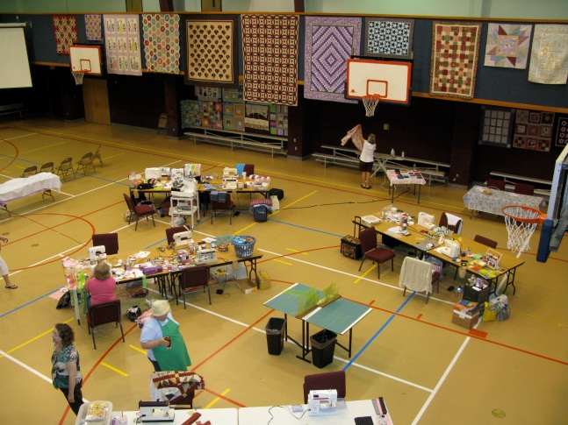
challenge quilt tops. Attendees will vote
for the cutest baby quilt tops, and prizes
will be awarded to the winners! Baby
quilts will be quilted by your hostesses
after the Quilt-a-thon and then given to
Pregnancy Lifeline of Fort Worth, a
charity we support.

The Ugly Fabric Challenge Fee of $5
needs to be paid in advance and must
accompany your registration fee.
Mini Classes

Attend one, none, or all of the
free mini sessions offered:
Easy Flying Geese
Prairie Points Made Easy
Speed Binding
Twister Pattern
Easy Pillow Cases

Things to Bring
Sewing machine
Personal project to work on

If spending the night
Bedding linens
Air mattress or cot
Towel

Prizes!
Several door prizes will be given daily.

Take a break at any time during the
event and enjoy the indoor walking
track or the WBC “quilter’s spa”. ☺
WBC Quilt-A-Thon
Registration Form

3-Day Participants By-The-Day Participants
Registration Fee $75 (required now) (required now) Registration Fee for 1 Day $30
Overnight Fee $20 (required now) Registration Fee for 2 Days $60
Roll Away Bed Rental $40 (required now, if needed) Overnight Fee for 1 Night $15
Ugly Quilt Challenge $5 (required now, if participating) Overnight Fee for 2 Nights $20
Amount Enclosed (required now, if needed) Roll Away Bed for 1 Night $20
(required now, if needed) Roll Away Bed for 2 Nights $40
If coming only 1 or 2 days, please circle which days you will be attending: (required now, if participating) Ugly Quilt Challenge $5
Thursday Friday Saturday Amount Enclosed

Name ____________________________________ Mail Registration Form to:
Phone ____________________________________
Sherry Slater
Address ____________________________________ Wedgwood Baptist Church
5522 Whitman Avenue
____________________________________ Fort Worth, TX 76133

Email ____________________________________ Make checks payable to
Wedgwood Baptist Church
Special Needs__________________________________

