Quick Table Topper
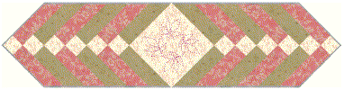
This 12" x 38" table topper makes up very quickly out of three fat quarters. Fix yourself a cup of hot tea and I bet you are done before it cools!
For illustrative purposes, we are using the color names shown in the example. You are free to use whatever color you please, of course:-))
Cutting
- Start by cutting an 9 1/2" x 21" strip from the three fat quarters. Cut the remainder of the fabric into four 2" strips.
- From both the pink and green 9 1/2" wide strips, cut a piece 12 inches long. It will measure 9 1/2" x 12". From the white 9 1/2" strip, cut a 9 1/2" x 9 1/2" square.
- Set aside the remaining 9 1/2" wide strips for use in another project.
- From three of the two inch wide strips of both the pink and the green, cut six 9 1/2" long strips, for a total of 12 strips. Avoid using the selvage.
- From the white two inch wide strips, cut two that are 12" long.
- Set aside the remaining 2" wide strips for use in another project.
Sewing and Cutting
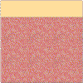
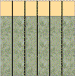
Sew a 2" x 12" white strip to one side of the 9 1/2" x 12" pink piece, making a 11" x 12" block. It should look like the block to the left. Repeat for the green. Press to the dark. Sub cut these blocks into six strips 2" x 11 1/2" long, like the block to the right.

Inventory
You should have:
- six 9 1/2" x 2" strips of pink
- six 9 1/2" x 2" strips of green
- two 12" x 2" strips of white
- six 11" x 2" two-part strips of pink and white
- six 11" x 2" two-part strips of green and white
- One 9 1/2" x 9 1/2" white square.
Now it is time to put them together, but first a note on pressing. It is almost impossible to keep your strips pressed to the dark. Rather, you should try to keep them all pressed away from the center square. Pin carefully as you piece this top together. Nesting the seams will help you keep your intersections sharp.
Sewing

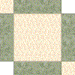
Sew a 9 1/2" long green strip to either side of the 9 1/2" x 9 1/2" white square, like the one on the left. Sew a two part green strip to the other two sides, placing the small square at opposite corners as shown to the right. Note that the strip will not go all the way to the end of the block. It feels really odd, but don’t worry about it, you are doing okay.

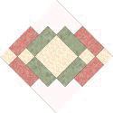
Sew a pink 9 1/2" x 2" strip to the two-part green strips on both sides of the table runner, starting with the end that has the little square. Remember, this strip won't reach all the way to the end of the previous strip. Now add a two-part pink strip, again starting at the end that has the little square. Keep adding strips, alternating colors and making sure to place the square on the correct corner. Do you see how it is going together almost like a log cabin?
After you have sewn all your strips, press carefully. Get all those seams going in one direction on the back so the top lays flat. Now place your ruler on the body of this top and rotary cut it straight. Make sure your 1/4" mark lines up with the point of the center square so you don't cut off your point when you sew on the binding. (the diagram below shows where you should lay the 1/4" mark on your ruler.)

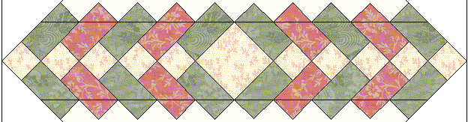
You are almost done! Just add batting and backing, quilt as desired. Use commercially prepared bias binding to make things easier on yourself, our make 92" of 1 1/2" wide straight-grain binding from the leftover white. Don't worry about the Quilt Police, they don't write tickets on any straight grain binding under 100" long.

