Cut the following strips: (in inches)
All seams sewn with a .25 (1/4 inch) seam
Use highly contrasting fabrics for best effect

Number x width x length

Black Fabric
Ba 4 x 1.5 x 39
Bb 4 x 2.5 x 39
Bc 4 x 3.5 x 39
Bd 2 x 4.5 x 39
Be 4 x 2 x 37
Bf 4 x 3 x 37
Bg 4 x 4 x 37
Bh 1 x 1.5 x 37

White Fabric
Wa 4 x 2 x 39
Wb 4 x 3 x 39
Wc 4 x 4 x 39
Wd 1 x 1.5 x 39
We 4 x 1.5 x 37
Wf 4 x 2.5 x 37
Wg 4 x 3.5 x 37
Wh 2 x 4.5 x 37

Sew the following strips together along their length
This will be set 1
Ba
Wa
Bb
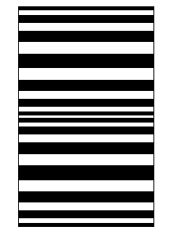
Wb
Bc
Wc
Bd
Wc
Bc
Wb
Bb
Wa
Ba
Wd
Ba
Wa
Bb
Wb
Bc
Wc
Bd
Wc
Bc
Wb
Bb
Wa
Ba

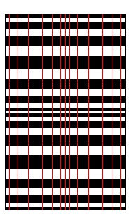
Cut the resulting fabric vertically into strips with the following widths (in inches)
The red lined in the picture are cut lines
1.5
2.5
3.5
4.5
3.5
2.5
1.5
1.5
2.5
3.5
4.5
3.5
2.5
1.5
In a second set, sew the following together along their length
This will be Set 2
We
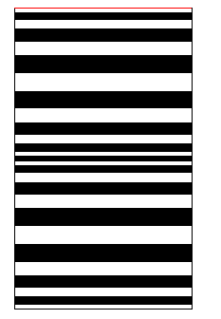
Be
Wf
Bf
Wg
Bg
Wh
Bg
Wg
Bf
Wf
Be
We
Bh
We
Be
Wf
Bf
Wg
Bg
Wh
Bg
Wg
Bf
Wf
Be
We

Cut the strips vertically into strips with the following widths (in inches)
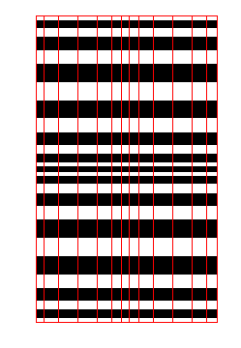
Cut on the red lines
2
3
4
4
3
2
1.5
2
3
4
4
3
2
**Make sure you keep the strips in order! I know, now I tell you…**

Start with the left-most strip from set 1 and alternate set 1 set 2 set 1 set 2 etc.

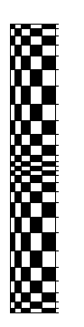
Continue in this manner until you have used all your strips, and if I’ve written this up correctly, you should have something that looks like this



