Card Trick Blocks – Placed on Point

YOU will need to decide how many blocks you will use, and therefore, how much fabric you will need; instructions here are for one individual block.

The popular Card Trick block is traditionally pieced with many triangles and then straight-set with in the quilt top. The following technique shows how to make this block easily with strip piecing and NO triangles!

After the blocks are completed, they are set in rows, on point, with only four corner triangles and as many large side triangles as you have rows….a much easier piecing method with more eye-appeal and a more polished looking setting overall.

The instructions here are for a finished 10” block. (As the block is designed on a 4-squares-by-4-squares configuration, it is easy to increase or decrease the size of the block by increasing your cut sizes in ½ inch increments.)

Choose four fabrics for your cards. Label them A B C D cards.
Choose one fabric for your background (bkgrd.)

CUT each card fabric into 3” wide by WOF (width of fabric) strips.
CUT one rectangle at 3” x 5½” from each card fabric strip. 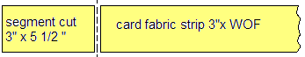

CUT bkgrd. fabric into four 3” squares.

SEW the card fabric strip lengths into pairs, A and B together, C and D together.
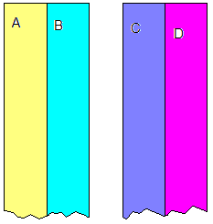

Cross cut these pairs into 3” segments.
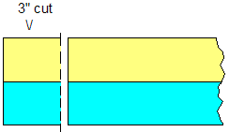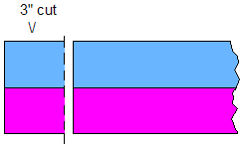

Match the seams and SEW to make a four patch. 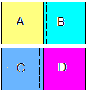

SEW one background square onto each end of the B rectangle and C rectangle.
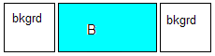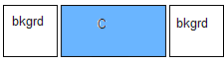

SEW an A rectangle to the left side of the ABCD four patch…watch your color placement.
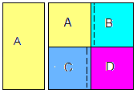

SEW a D rectangle to the right side of the four patch. 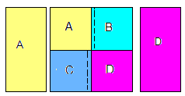
You have now made the middle section of your block.

SEW the last two sections following the diagram below to complete the block.
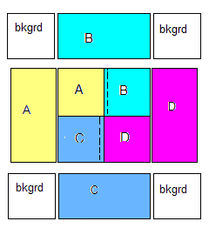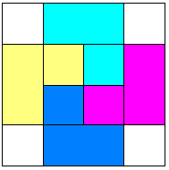

Now, turn your block on point…….see, there’s your card trick and not a triangle in sight!
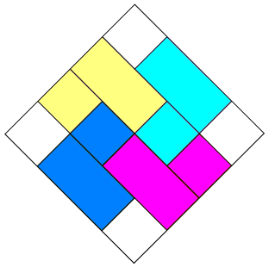

Setting instructions follow.

On point quilts are sewn together in diagonal rows starting with one corner.
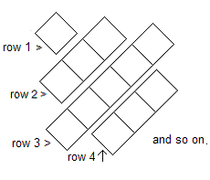

SEW row 2 blocks together side by side as usual.
SEW the subsequent rows the same way. The longest row will be diagonally through the approx. middle of your top.

*The setting triangles will be sewn to the ends of each row.
*Setting triangle CUTTING instructions are below at the *.
Read those instructions now, cut your setting triangles, then come back to this section.*

After you’ve cut them, SEW the side setting triangles to the ends of EACH row, with one triangle side even with the block side, so that the oversized triangle points hang off on the same side of the block each time.
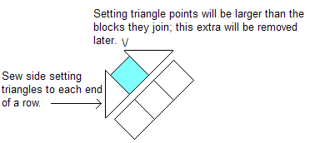
.

Now TRIM off the overhanging tips of the triangles parallel to the side of the pieced block so you can sew the next row on.
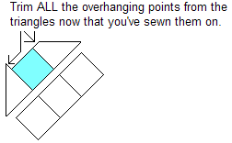

Press the top. Leave the 4 corner triangles to SEW on last.
Your quilt should look at this now….though your number of rows may be different. Notice how the block points do not touch the edges of the top, this is intentional.
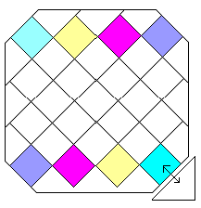
Your sides will be uneven and raggedy, that’s fine, you will square it up soon.

SEW on your corner triangles, being sure to center the triangle over the block, shown here by the arrow.
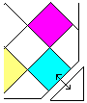

Now you will trim and square up the top, being sure to leave the same amount of “float” on all sides of the quilt. You can leave a large amount of fabric around the blocks or trim until the points are almost touching the seams at the edge. “Floating” your blocks keeps you from losing your block points into the seam edge of the border and makes the design crisper.

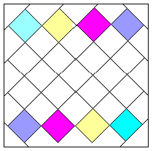

I personally find it effective to add a narrow (1” – 1.5”) border – which I call a “stopper border” (that which stops the action of the blocks, think of it as the beveled inner edge of a framed picture’s mat ) at this point before adding a wider border.

