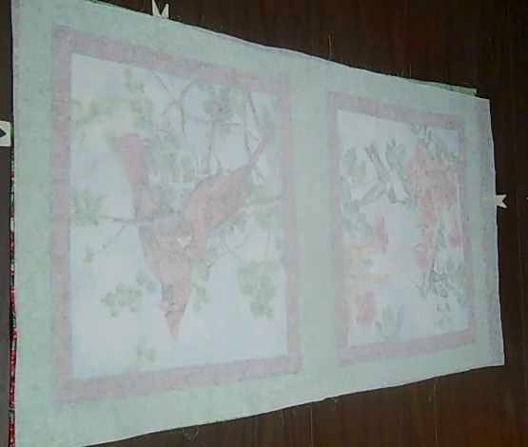
Step 1 – Fuse the craft fuse onto the back of the fabric that you are going to use. Hint!! Press on the material side to fuse the two together, it will have less wrinkles and fuses better.

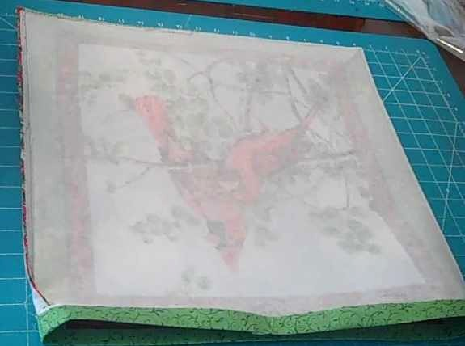
Step 2 – Fold the material over and sew along both sides and the bottom (if 2 pieces), as shown to the left.

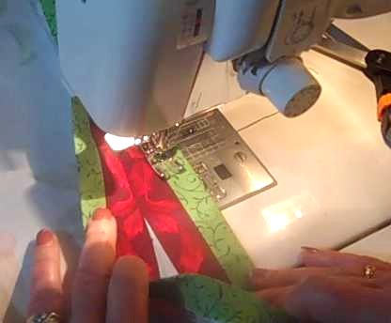
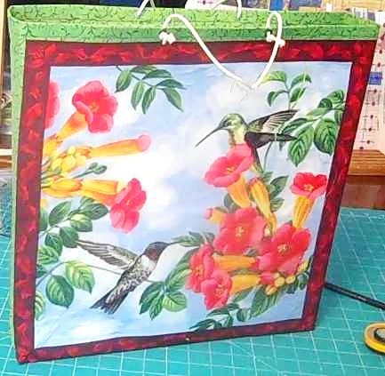
Step 3 – bend the open ends over and sew along the bottom of the fold on the inside, as illustrated to the right.

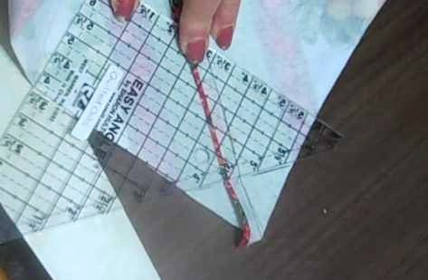
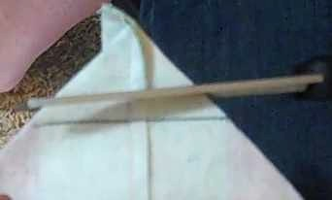
Step 4 - Fold each corner in and mark how wide that you want the bottom to be, and then sew on the line, and cut off the excess as illustrated to the left, and below.
The wider the corner, the wider the bag. The bottom will be twice the size of the fold. 1” fold = 2” bottom.

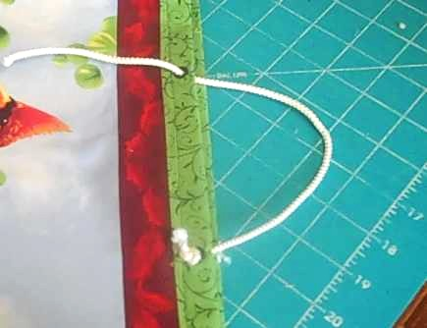
Step 5 – Cut the excess off and turn the bag right side out and set a couple of grommets into the bag. String some cord through them. Tie knots on each end.

Press the sides and bottom.

Step 6 – Your finished bag should look similar to the illustration below.


Quilted Oak
Quilt shop – Fabric - Classes

145 Lester Dr, Camdenton, MO 65020
(5 miles south of Camdenton off of Old Highway 5)
WWW.Quiltedoaks.com
573-346-5360
Lanny Logan & Marlene Horning Jackson

These instructions/templates are copyrighted and may not be copied without permission. c 2011

