Strip Chain Paper Piecing

- Tools
  - Index card – I have a 5x8 – use what you have
  - Ruler – I just use my 6x12 – use what you have
  - Rotary cutter 45mm – use what you have
  - Simply Amazing Translucent Foundation Paper
    - http://webstore.quiltropolis.net/stores_app/Browse_Item_Details.asp?Shopper_id=2670910955162670&Store_id=585&page_id=23&Item_ID=1087
  - Seam Roller – if the seam can’t be finger pressed
    - http://webstore.quiltropolis.net/stores_app/Browse_Item_Details.asp?Shopper_id=2670910955162670&Store_id=585&page_id=23&Item_ID=1085
- Dear Jane L4 Paper Piecing Pattern
  - Cut the units apart (A, B, C, D, E)
- Cut your fabric into strips – I’m cutting the strips wide because your learning a new method
  - White/red fabric = 2.5 inches my strips are about 20 inches long
  - Indigo fabric = 2.5 inches, if I wasn’t trying to teach this I would have cut the indigo fabric would be 1.25 inches wide.
- Put right sides of fabric together with the white fabric on top
  - All section #1 on the units are white and all section #2 on the units are blue.
    - Line up the paper on the strips of fabric positioning the strip with the white fabric ¼ over into the #2 section – this is easy to do if you use that paper I mentioned because you can see thru it.
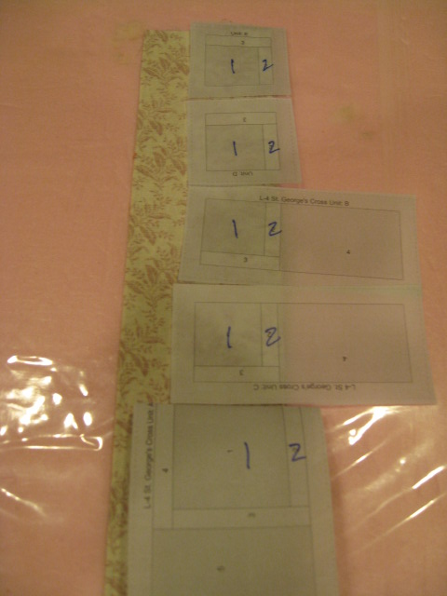
    - Sew on the line between 1 and 2 on all the units down the strip of fabric
    - Don’t be afraid to move the strip forward to the next section to avoid sewing thru every seam or section that might be in your way.
    - See, in this pic you can see how I shifted the strip so that I didn’t sew thru section 7 on unit A to get to the line between 1 & 2.
    - 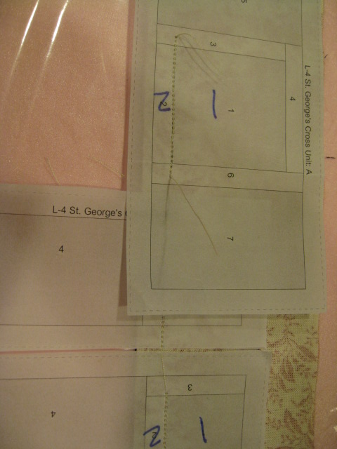
  - Finger press the blue fabric over to cover section #2. If it gives you a hard time hit it with the seam roller.
    - 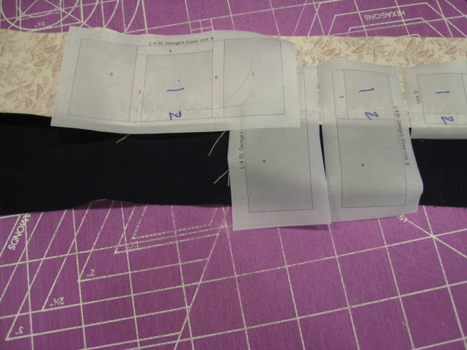
  - Cut apart and trim to add on section 3.
  - 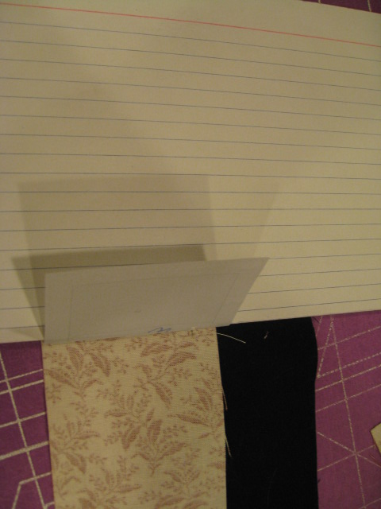
  - Section 3 is indigo and again just chain piece them down a indigo strip of fabric.
    - 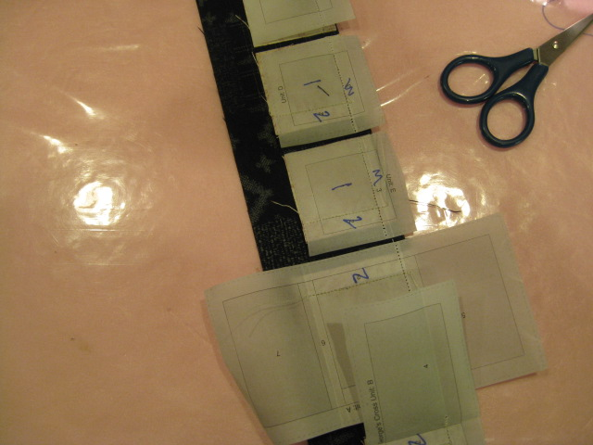
  - Finger press the indigo fabric over section 3 and trim
    - 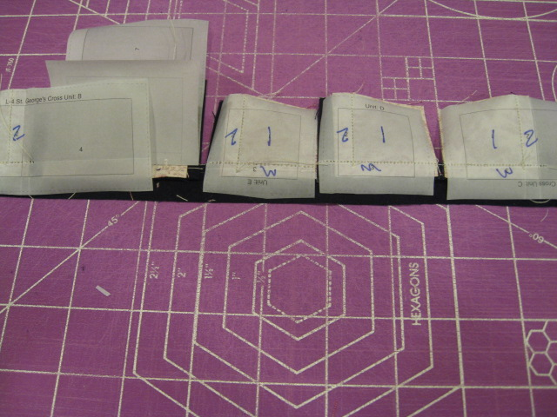
    - 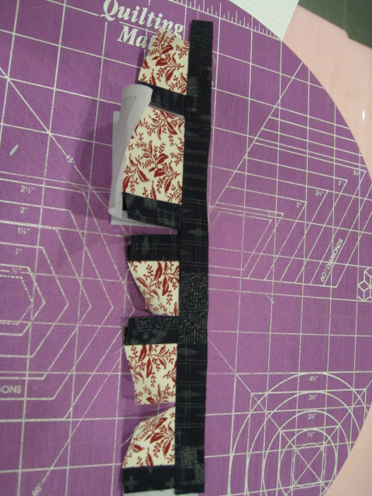
  - Cut the Units apart
    - 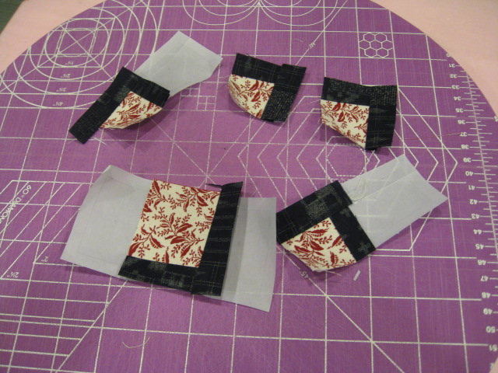
  - Units D & E are complete
  - Trim remaining 3 units to prepare for section 4
    - Units B & C have white
      - I sew one edge of the white strip to unit b, finger press over section 4 and sew unit C on the other end.
      - 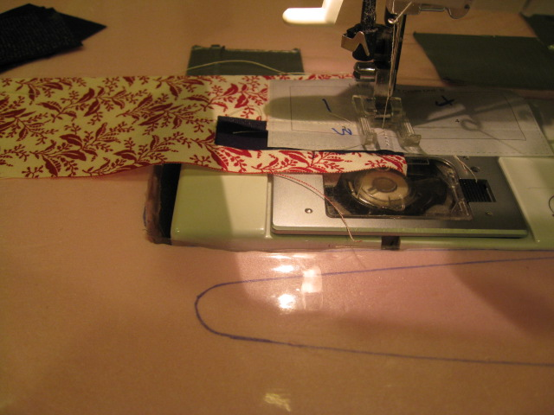
      - 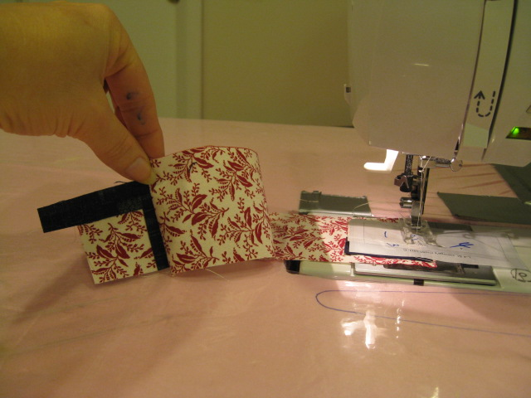
      - 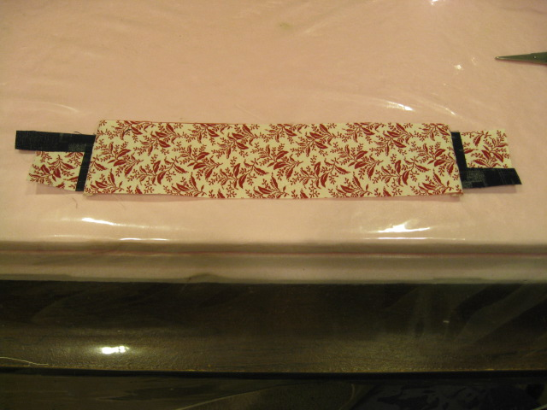

      - Sew an indigo strip onto Unit A section 4 and finger press
    - Units B & C are done
    - Prepare section 5 on unit A
      - add a white strip and finger press over.
      - 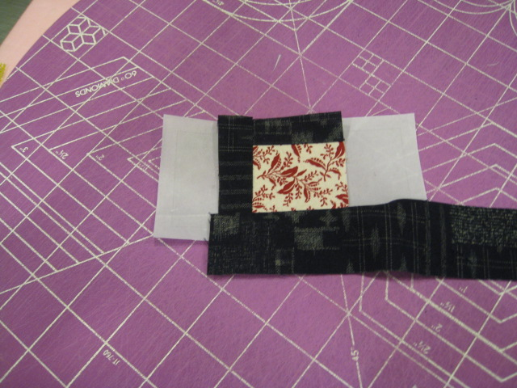
      - 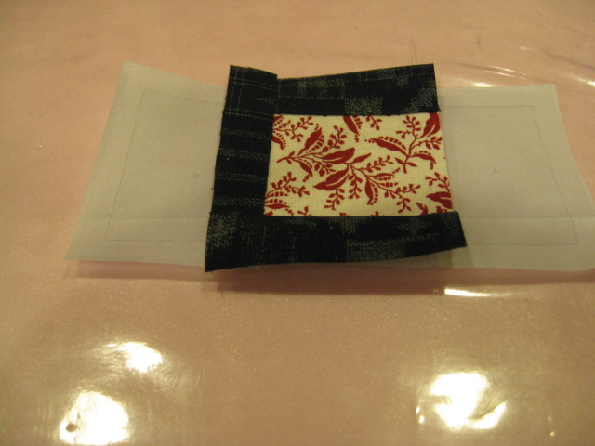
      - 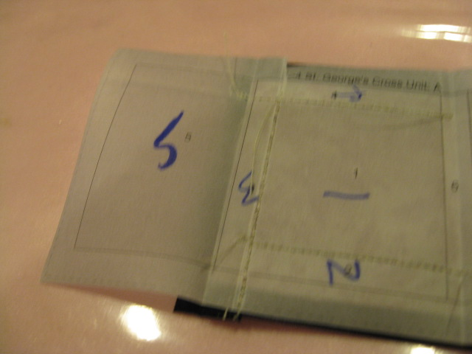
      - 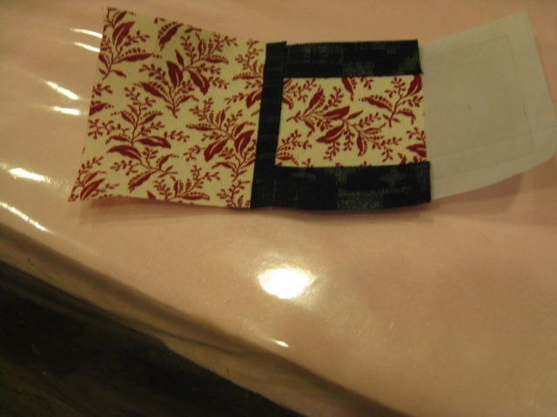

    - Trim and add an indigo to section 6
      - 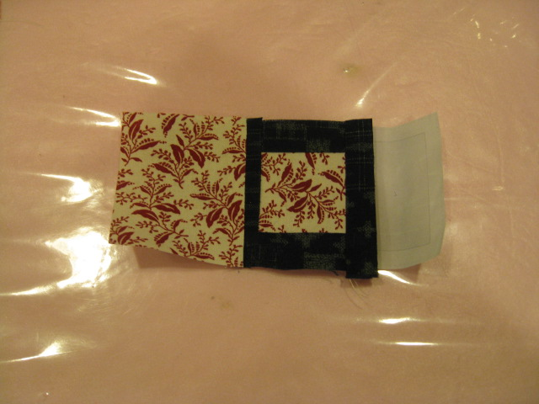
    - Trim and add a white in section 7
      - 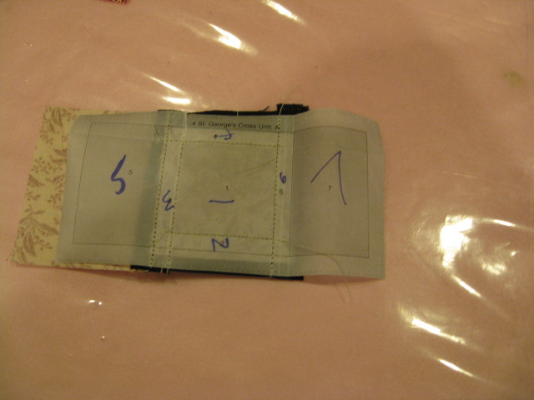
      - 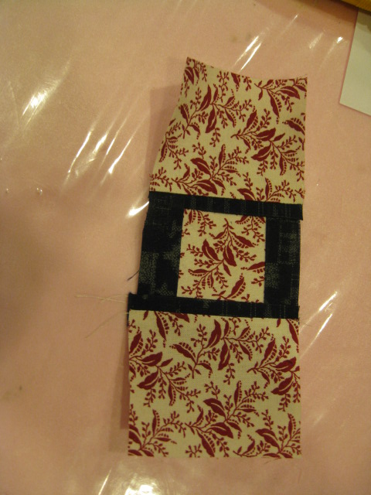
- Trim all units down to the outer seam lines and put the block together
  - 